USCS307: Web Programming -practical

|  |  |  |  |  |  |
| --- | --- | --- | --- | --- | --- |
| Sno | Topic | Hyperlink |  |  |  |
| 1 | 1. Design a webpage that makes use of | http://pr1 |  |  |  |
|  | a. Document Structure Tags  b. Various Text Formatting Tags  c. List Tags  d. Image and Image Maps |  |  |  |  |
|  |  |  |  |  |  |
|  | 2. Design a webpage that makes use of | http://pr2 |  |  |  |
|  | a. Table tags  b. Form Tags (forms with various form elements) | http://pr2b |  |  |  |
|  | c. Navigation across multiple pages  d. Embedded Multimedia elements |  |  |  |  |
|  | 3. Design a webpage that make use of Cascading Style Sheets with | http://pr3 |  |  |  |
|  | a. CSS properties to change the background of a Page |  |  |  |  |
|  | b. CSS properties to change Fonts and Text Styles |  |  |  |  |
|  | c. CSS properties for positioning an element |  |  |  |  |
|  | 4. Write JavaScript code for | http://pr4 |  |  |  |
|  | a. Performing various mathematical operations such as calculating factorial / finding Fibonacci Series / Displaying Prime Numbers in a given range / Evaluating Expressions / Calculating reverse of a number |  |  |  |  |
|  | b. Validating the various Form Elements |  |  |  |  |
|  | 5. Write JavaScript code for | http://pr5 |  |  |  |
|  | a. Demonstrating different JavaScript Objects such as String, RegExp, Math, Date |  |  |  |  |
|  | b. Demonstrating different JavaScript Objects such as Window, Navigator, History, Location, Document, |  |  |  |  |
|  | c. Storing and Retrieving Cookies |  |  |  |  |
|  | 6. Create a XML file with Internal / External DTD and display it using | http://pr6 |  |  |  |
|  | a. CSS b. XSL |  |  |  |  |
|  | 7. Design a webpage to handle asynchronous requests using AJAX on | http://pr7 |  |  |  |
|  | a. Mouseover b. button click |  |  |  |  |
|  | 8. Write PHP scripts for | http://pr8 |  |  |  |
|  | a. Retrieving data from HTML forms |  |  |  |  |
|  | b. Performing certain mathematical operations such as calculating factorial / finding Fibonacci Series / Displaying Prime Numbers in a given range / Evaluating Expressions / Calculating reverse of a number |  |  |  |  |
|  | c. Working with Arrays |  |  |  |  |
|  | d. Working with Files (Reading / Writing) |  |  |  |  |
|  | 9. Write PHP scripts for | http://pr9 |  |  |  |
|  | a. Working with Databases (Storing Records / Reprieving Records and Display them) |  |  |  |  |
|  | b. Storing and Retrieving Cookies |  |  |  |  |
|  | c. Storing and Retrieving Sessions |  |  |  |  |
|  | 10. Design a webpage with some jQuery animation effects. | http://pr10 |  |  |  |
|  |  |  |  |  |  |

[**Practical 1**](http://pr1)

1.Design webpage that makes use of

**Code:**

<html>

<head>

<title>Image mapping</title>

</head>

<body>

<img src="ss.jpg" height=100% width=100% alt="saturn" usemap="#hmap">

<map name="hmap">

<area shape="circle" coords="985,385,120" href="saturn2.html">

</map><br>

</body>

</html>

**Output:**

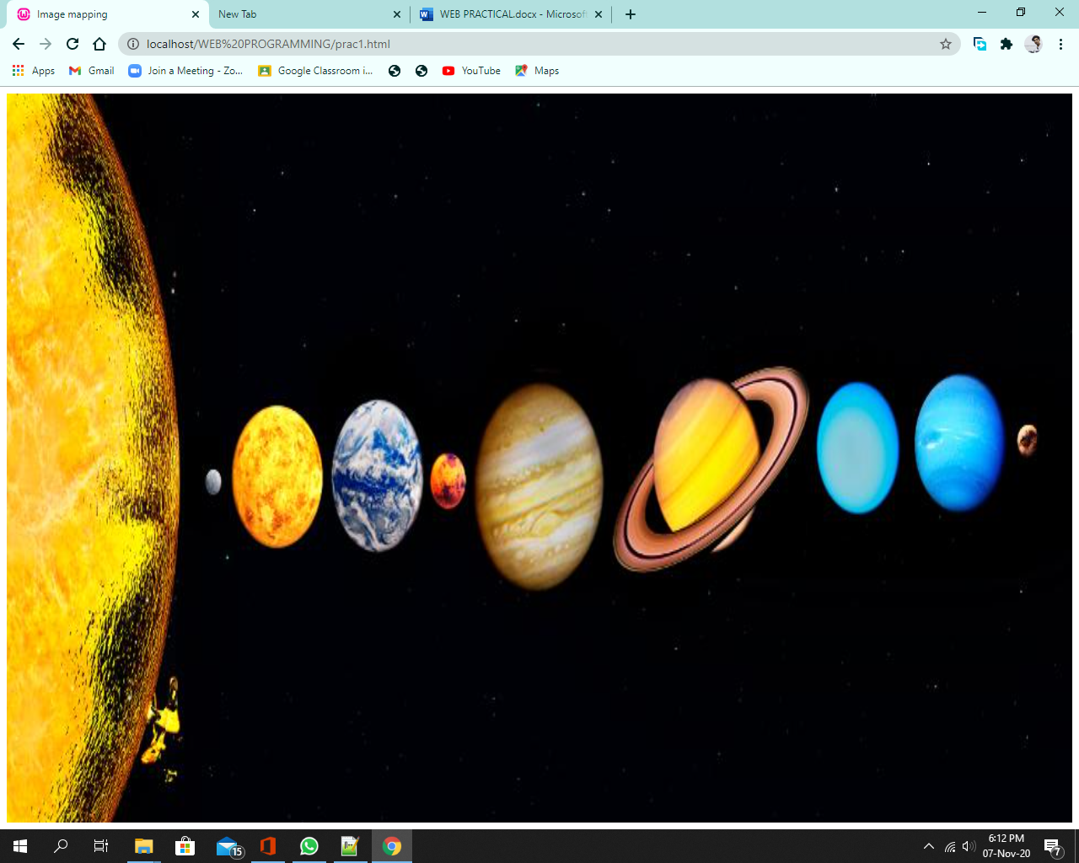

(B)

**Code:**

<html>

<head>

<title>practical 1.1</title>

</head>

<body>

<strong>1.1 A)To study Document Structure and B)Text formatting Tags</strong>

<p>

This is the complete source code for Quake 2,<b> Version 3.19</b>, buildable with <u>Visual C++ 6.0.</u> <br>

The Linux Version should be buildable, but we haven't tested it for release.<br>

The code is all licensed under the term GPL <i>(gnu public license)</i>. You should read the entire license, <br>

but the gist of it is that you can do anything you want with the code, <br>

including sale your new version. The catch is that if you distribute the new binary versions, <br>

you are required to make the entire source code available for free to every one.

</p>

<center>

The primary intent of this release is for entertainment & educational purpose but <br>

the GPL does allows commercial exploitation or if you obey thee full license.<br>

If you want to do something commercial & you just cant bare to have your source changes release,<br>

we could still negotiate a separate license agreement (for $$$), <br>

but I would encourage you to just live with the GPL.<br>

</center>

<p align=right>

All of the Q2 data files remain copyrighted & licensed under the original terms,<br>

so you cannot redistribute data from the original game,<br>

but if you does a true total conversion, <br>

you can create a standalone game based on this code.

</p align=right>

Thanks to Robert Duffy for doing the grunt work of building this release.<br>

<address>

<mark>John Carmack </mark> <br>

ID Software <br>

Address: <br>

59 Temple Place - Suit 330,<br>

Boston, MA 02111-1307, USA <br>

<a>John.Carmack@sunorg.co.in</a>

</address>

</body>

</html>

**Output:**

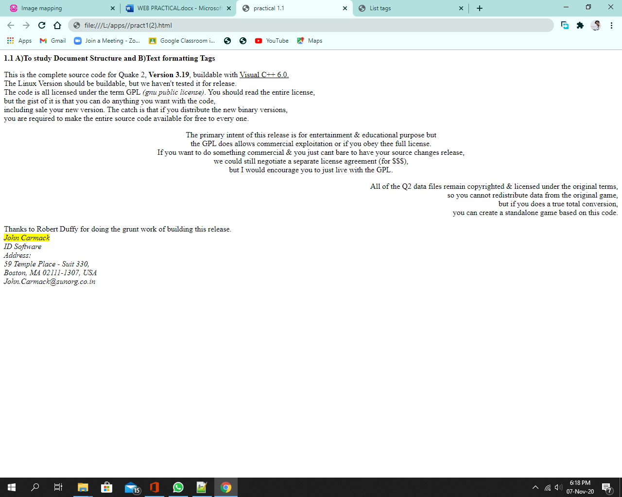

(C)

**Code:**

<html>

<head>

<title>List tags</title>

</head>

<body>

<ol>

<li> In the toolbox, click. </li>

<li> To create a text frame, drag the pointer diagonally <br> to the size you want </li>

<li> on the text toolbar, click the font ,size, and <br> style you want for the text </li>

<ul>

<li> Move or enlarge the text frame. </li>

<li> Click a color to change the color of the text. </li> <br> <br>

<ol>

<li> on the <b>image</b> menu, click <b>Attributes</b>. </li>

<li> click the unit of measurement you want to use for the width and height. </li>

<li> Type the measurements in <b> Width</b> and <b>Height</b>. </li>

</ol>

</ul><br> <br>

<ul>

<li> Click in the toolbox to insert the text on a colored background.

<br> Then right-click in the color box change the background color. </li>

</ul>

<li>Click inside the text frame, type the text, and <br>

then do any of the following needed.</li>

</ol> <br>

Notes <br>

<ul>

<li> You can view the text toolbar by clicking the <b> View</b> <br>

menu and then clicking <b> Text Toolbar </b>. If it obscures <br>

part of the <b>Paint</b> window, you can drag the toolbar <br>

to any location in the window. </li>

<li> When the text tools are selected, you can paste <br>

text only. You cannot paste graphics. </li>

<li> You can undo up to three changes by clicking the <br>

<b> Edit</b> menu and then clicking<b> Undo</b> for each change. </li>

</ul>

</body>

</html>

**Output**:

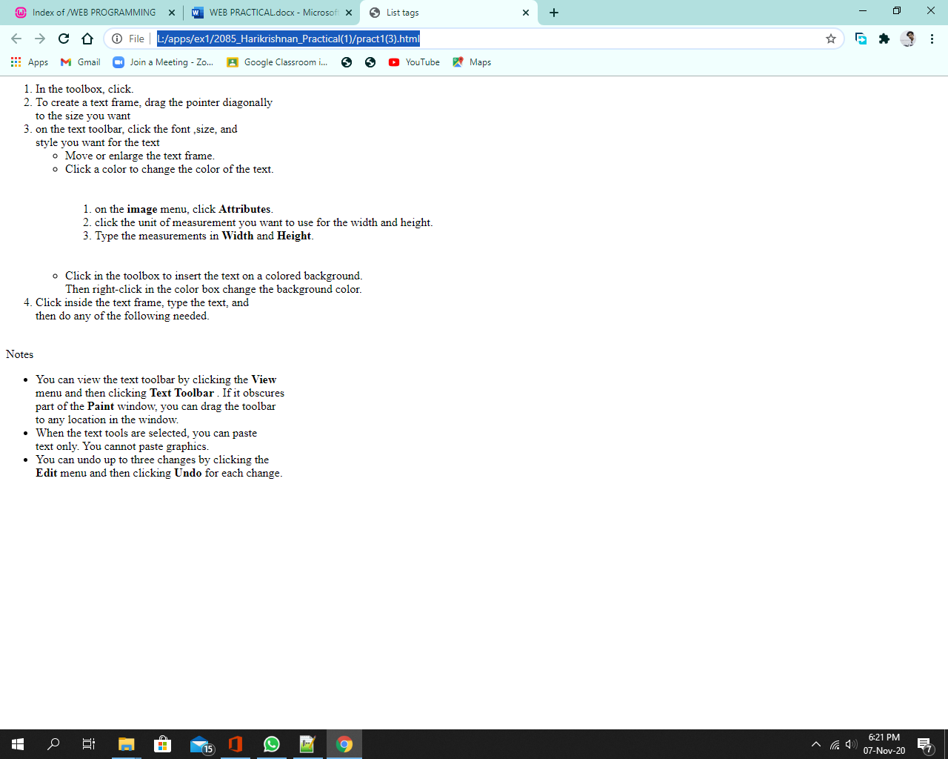

**Code:**

<html>

<head>

<title>practical 1(c)</title>

</head>

<body bgcolor="yellow">

<h3> Ordered list </h3><br>

<ol type="1">

<li>INDIA</li>

<li>PAKISTAN</li>

<li>CHINA</li>

<li>NEPAL</li>

</ol>

<h3>Unordered list</h3> <br>

<ul type="square">

<li> BLUE</li>

<li>GREEN</li>

<li>YELLOW</li>

<li>WHITE</li>

<li>RED</li>

<li>GOLDEN</li>

<li>SILVER</li>

<li>BROWN</li>

<li>GREY</li>

</ul>

<h3>Both Ordered & Unordered list</h3> <br>

<ul type="disc">

<li>MOBILES</li>

<ol type="1">

<li>APPLE</li>

<li>SAMSUNG</li>

<li>NOKIA</li>

</ol>

</ul>

<ul type="disc">

<li>TV</li>

<ol type="1">

<li>LG</li>

<li>PANASONIC</li>

<li>SONY</li>

</ol>

</ul>

</body>

</html>

**Output:**

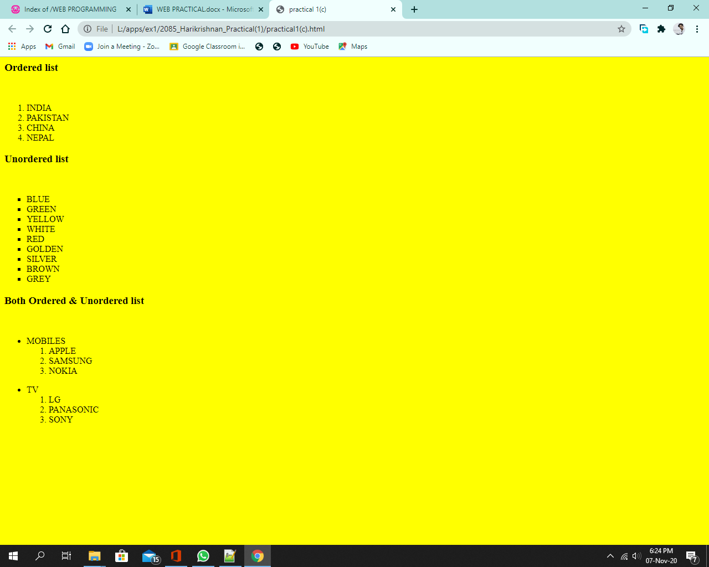

**Code:**

<html>

<head>

<title>saturn</title>

</head>

<body>

<center>

<img src="./assets/saturn2.jpg" height=50% width=50% alternate="saturn"><br>

<b><h1> SATURN</h1></b><br>

Saturn is the sixth planet from the Sun and the second-largest in the Solar System, after Jupiter. <br>

It is a gas giant with an average radius of about nine times that of Earth. <br>

It only has one-eighth the average density of Earth; however, with its larger volume,<br>

Saturn is over 95 times more massive.<br>

<b>Category: </b> Planet, Gas giant<br>

<b>Star system:</b> Solar System<br>

<b>Orbits:</b> Sun<br>

<b>Missions sent here:</b> Cassini–Huygens<br>

<a href="index.html"><h2>Go back</h2></a>

</center>

</body>

</html>

**Output:**

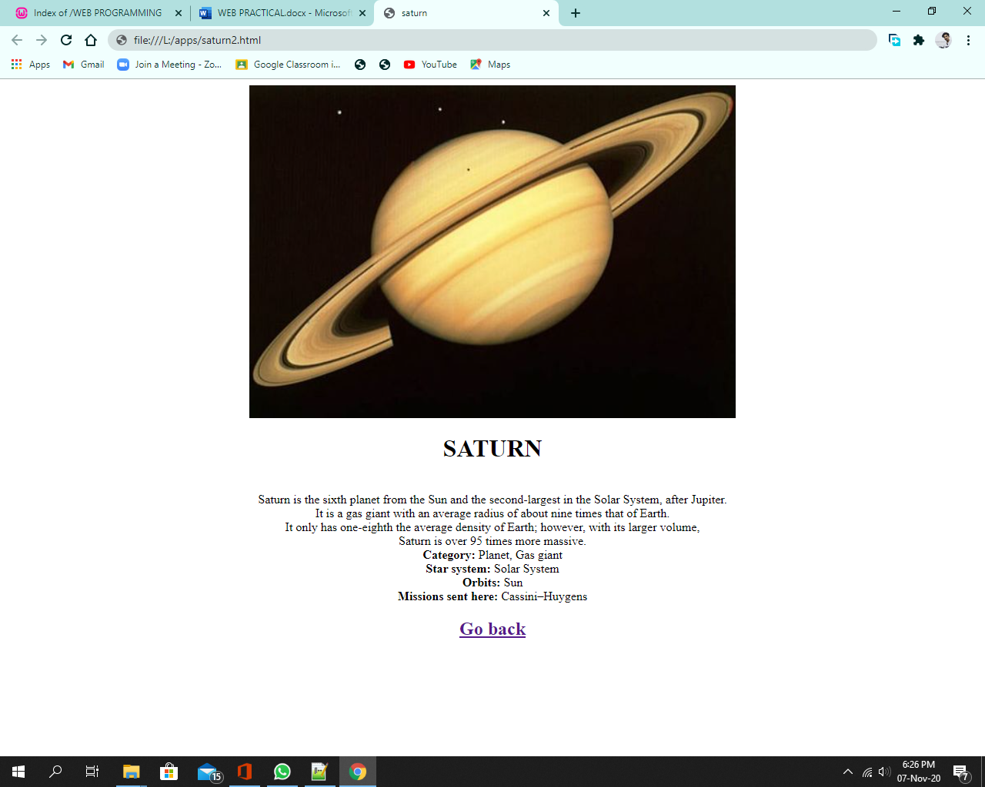

[**Practical 2**](http://pr2)

1.Design web page makes use of.

**Code:**

<!DOCTYPE html>

<html>

<head>

<title>

Calendar

</title>

</head>

<body> <h3 align=centre>Calendar</h3>

<table border=1 align="centre" cellpadding=5>

<tr>

<th colspan=2>April</th>

<th colspan=2>ABC CORP</th>

<th colspan=2>04-2004</th>

</tr>

<tr align="centre">

<font color="red">

<th color=red><font color="red">SUN</font></th>

<td></td>

<td><font color="red">4</font></td>

<td><font color="red">11</font></td>

<td><font color="red">18</font></td>

<td><font color="red">25</font></td>

</font>

</tr>

<tr align="center">

<th>MON</th>

<td cellpadding=10> <img src="clock.png" alt"Alarm" height=30 width=30></td>

<td>5</td>

<td>12</td>

<td>19</td>

<td>26</td>

</tr>

<tr align="center">

<th>TUE</th>

<td> <img src="gym.png" alt"Mails" height=30 width=30></td>

<td>6</td>

<td>13</td>

<td>20</td>

<td>27</td>

</tr>

<tr align="center">

<th>WED</th>

<td> <img src="vegi.png" alt"Remember" height=30 width=30></td>

<td>7</td>

<td>14</td>

<td>21</td>

<td>28</td>

</tr>

<tr align="center">

<th>THUR</th>

<td>1</td>

<td>8</td>

<td>15</td>

<td>22</td>

<td>29</td>

</tr>

<tr align="center">

<th>FRI</th>

<td>2</td>

<td>9</td>

<td>16</td>

<td>22</td>

<td>30</td>

</tr>

<tr align="center">

<th>SAT</th>

<td>3</td>

<td>10</td>

<td>17</td>

<td>24</td>

<td></td>

</tr>

<tr align="center">

<th COLSPAN=2>Sponsors</th>

<td><img src="soldier.png" alt"Remember" height=30 width=30></td>

<td><img src="INDIA.png" alt"Remember" height=30 width=30></td>

<td><img src="japan.png" alt"Remember" height=30 width=30></td>

<td></td>

</tr>

<tr align="center">

<th COLSPAN=6>April 2004</th>

</tr>

</table>

<br><br>

<center>PRACTICAL 2 (Telephone Bill): <a href="prac2a.html">Click here</a></center>

</body>

</html>

**Output:**

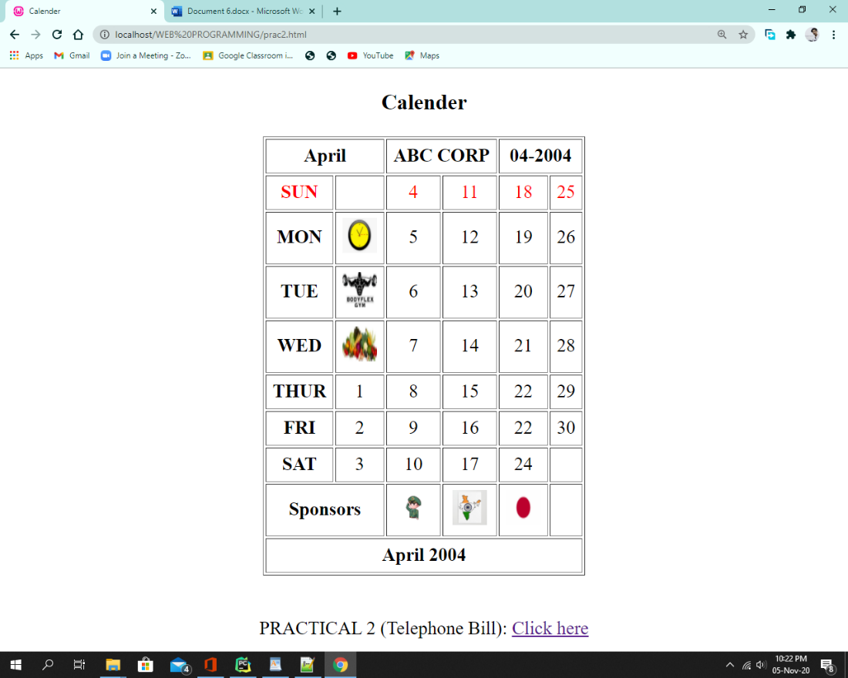

[**Telephone Bill**](http://pr2b)

<!DOCTYPE html>

<html>

<head>

<title>Telephone Bill</title>

</head>

<STYLE>

TABLE,TH,TD{

FONT-FAMILY: ARIAL, SANS-SERIF;

BORDER: 1PX SOLID BLACK;

BORDER-COLLAPSE: COLLAPSE;

}

</STYLE>

<body>

<center>Telephone Bill

<table align="center" border="1" cellpadding="5" width="950">

<tbody>

<tr >

<th colspan="2" align="center"><b><u><center>Subscriber's Name and Address</b></u></th>

<td STYLE="COLOR:blue;" colspan="2" align="center"><i>consumer no</i></td>

<th colspan="3" align="left"> <b><u>P.O.Stamp</b></u></th>

</tr>

<tr>

<td colspan="2"><center>Leena P, Cross roads<br><br>Off Haji Ali Road.</td>

<td colspan="2"><center>PL 0051077</td>

<td colspan="3"></td>

</tr>

<tr>

<td colspan="1"><center>Telephone<br>no</td>

<td colspan="1"><center>Type</td>

<td colspan="2"><center>Bill date</td>

<td colspan="2"><center>Due Date</td>

<td colspan="1"><center>Pay By Date</td>

</tr>

<tr align="center">

<td>575077</td>

<td>Genl res Perm</td>

<td colspan="2">01- Aug-2001</td>

<td colspan="2">18-Aug-2001</td>

<td>25-Aug-2001</td>

</tr>

<tr align="center">

<td>OPENING <br>METER<br> READING</td>

<td>CLOSING METER <br>READING</td>

<td >METERED<br> CALLS</td>

<td >DEBIT CALLS</td>

<td>CREDIT CALLS</td>

<td>FREE CALLS</td>

<td>CHARGEABLE<br>CALLS</td>

</tr>

<tr align="center">

<td>1052</td>

<td>1297</td>

<td>245</td>

<td>0</td>

<td>0</td>

<td>150</td>

<td>95</td>

</tr>

<tr align="center">

<td colspan="4">DETAILS</TD>

<TD>ITEM</TD>

<TD>PERIOD</TD>

<TD>AMOUNT</TD>

</TR>

<TR ALIGN="CENTER">

<TD>Rate</td>

<td>No. of Calls</td>

<td colspan="2">Charge</td>

<td>Rent</td>

<td>10/09/97 to<br> 31/10/98</td>

<td>200.00</td>

</tr>

<tr align="center">

<td colspan="2">AMT ON/ BEFORE PAY BY DATE</td>

<td colspan="2">290</td>

<td>ITX CALLS</td>

<td>16/05/97 to <br>15/07/97</td>

<td>0.00</td>

</tr>

<tr align="center">

<td colspan="2">AMT AFTER PAY BY DATE</td>

<td colspan="2">300</td>

<td>MISC</td>

<td>TAX</td>

<td>14.00</td>

</tr>

<tr align="center">

<td colspan="2"></td>

<td colspan="2"></td>

<td colspan="2">TOTAL</TD>

<td>290.00</td>

</tr>

<tr>

<td colspan="4"></td>

<td colspan="2" align="left">ADDRESS</TD>

<TD></TD>

</TR>

<TR>

<TD COLSPAN="4"></TD>

<TD COLSPAN="3">PLEASE PAY BEFORE DUE DTE AND AVOID DISCONNECTION<br><br><br></TD>

</TR>

<TR>

<TD COLSPAN="4">E & O.E. PLEASE SEE OVERLEAF FOR CODES / INSTRUCTIONS</TD>

<TD colspan="3">Account Officer</td>

</tr>

</tbody>

</table><br>

<center>PRACTICAL 2 (Audio & Video): <a href="audio.html">Click here</a></center>

</body>

</html>

Output:

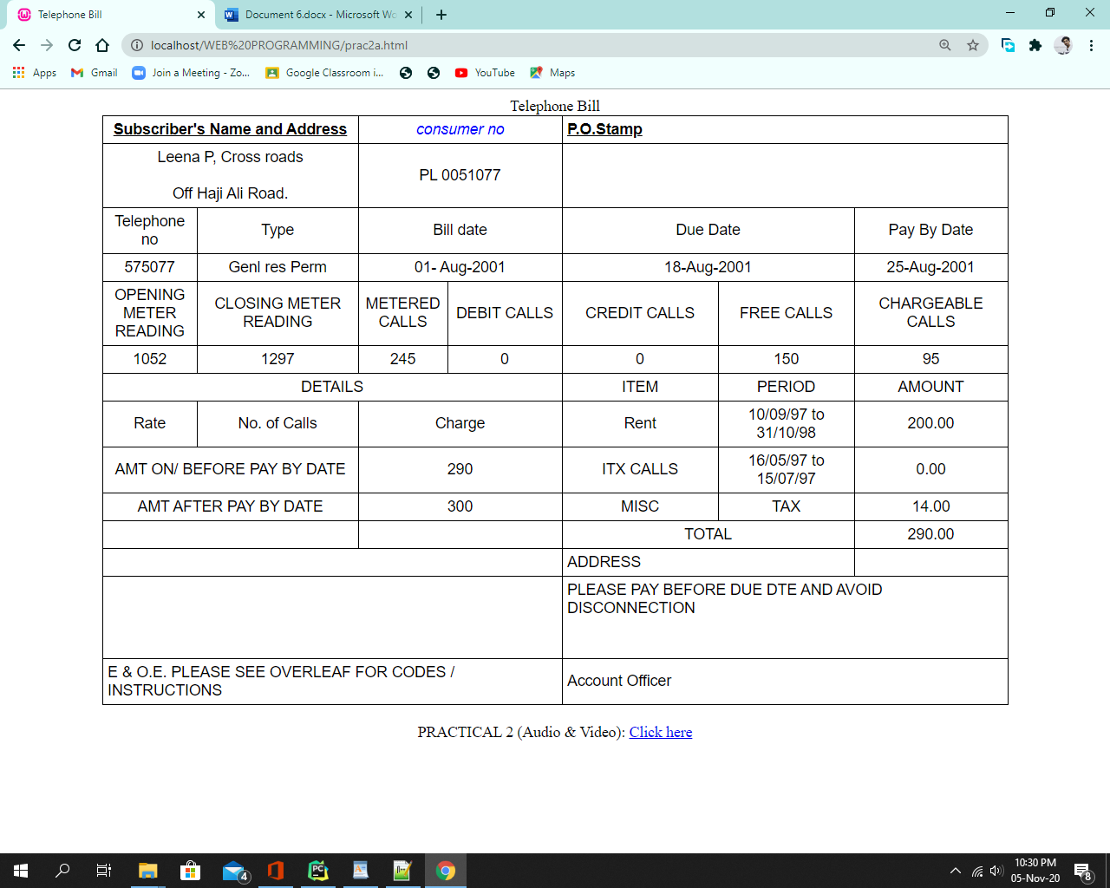

<!Doctype html>

<html>

<head>

<title>Audio Tag</title>

</head>

<body>

<center>

<body bgcolor="white">

<font color="black">

<h2>VIDEO</h2>

</font>

<video width="450" height="400" controls><br>

<source src="video.mp4"autoplay="autoplay">

<p>No support for HTML5<code>audio></code>element.</p>

</video>

<font color="black">

<h2>AUDIO</h2><br>

</font>

<audio controls><br>

<source src="music.mp3" autoplay="autoplay">

<p>No support for HTML5<code>audio></code>element.</p>

</audio> <br>

<font color="grey">

<center>PRACTICAL 2 (Frame): <a href="frame.html">Click here</a></center>

</font>

</body>

</html>

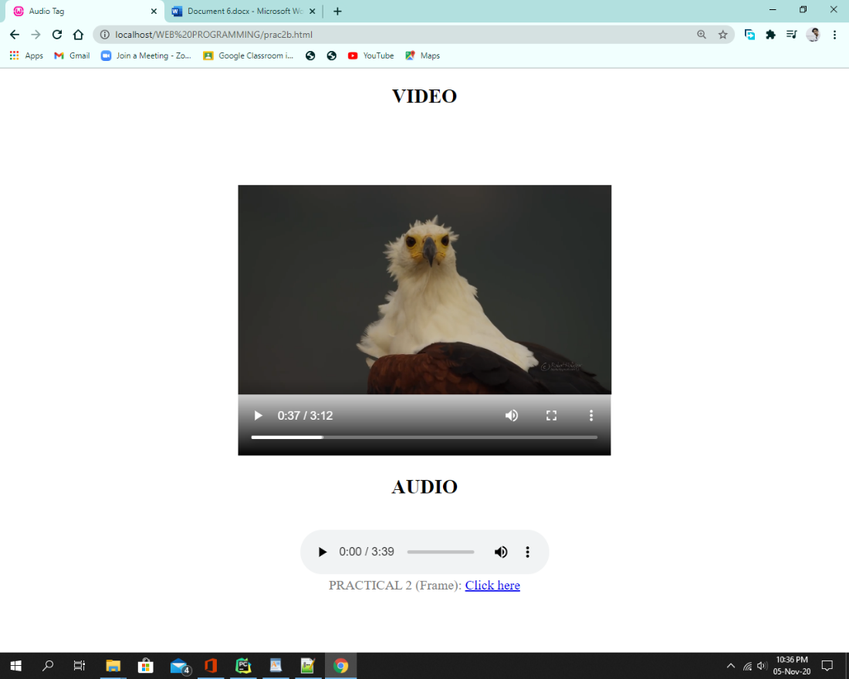

FRAME :

Code:

<html>

<head>

<meta charset="utf-8">

<title>Frameset Typical design </title>

<Frameset COLS="25%,80%">

<Frame src="leftframe.html" Noresize Name="left" Frameborder=2>

<Frameset rows="20%,50%,30%">

<Frame src="rightframe.html" Noresize Name="top" Frameborder=2>

<Frame src="Topframe.html" Noresize Name="Main" Frameborder=2>

<Frame src="bottomframe.html" Noresize Name="Bottom" Frameborder=2>

</Frameset>

</Frameset>

</head>

</html>

------------------------------------------------------------------------------------------------------------------------------------------

<!doctype html>

<html>

<head>

<meta charset="utf-8">

<title>leftframe</title>

</head>

<body bgcolor="DodgerBlue">

<H1>LEFT FRAME</H1>

<p></p>

</body>

</html>

<!doctype html>

<html>

<head>

<meta charset="utf-8">

<title>rightframe</title>

</head>

**Output**:

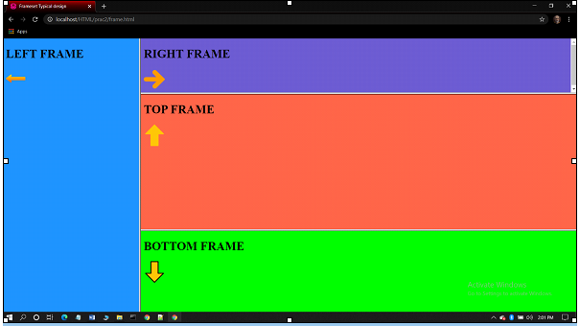

Code :

<html>

<head>

<title>Form Page</title>

<h1 align="center">Computer Society of India</h1>

</head>

<body >

<h4><font color="LightSeaGreen">Annual convention 2020</font></h4>

<h3><font color="MidnightBlue">Participant's Registration Form</font></h3>

<form>

<label for="name">1. Name of Participant:</label> &nbsp &nbsp &nbsp &nbsp &nbsp &nbsp

<input type="text" id="name" name="fname"><br><br>

<label>&nbsp &nbsp Personal Information</label><br><br>

<label>&nbsp &nbsp Address:</label>

<label for="street">Street:</label> &nbsp &nbsp &nbsp &nbsp &nbsp &nbsp &nbsp &nbsp &nbsp &nbsp

<input type="text" id="street" name="street"><br><br>

<label for="town">&nbsp &nbsp Town:</label>&nbsp &nbsp &nbsp &nbsp &nbsp &nbsp &nbsp &nbsp &nbsp &nbsp &nbsp &nbsp &nbsp &nbsp &nbsp &nbsp &nbsp &nbsp

<input type="text" id="town" name="town"><br><br>

<label for="state">&nbsp &nbsp State :<label>&nbsp &nbsp &nbsp &nbsp &nbsp &nbsp &nbsp &nbsp &nbsp &nbsp &nbsp &nbsp &nbsp &nbsp &nbsp &nbsp &nbsp &nbsp

<input type="text" id="state" name="state"><br><br>

<label for="code">&nbsp &nbsp Pin code :</label> &nbsp &nbsp &nbsp &nbsp &nbsp &nbsp &nbsp &nbsp &nbsp &nbsp &nbsp &nbsp &nbsp &nbsp &nbsp

<input type="number" id="code" name="code"><br><br>

<label for="mail">&nbsp &nbsp Email :</label>&nbsp &nbsp &nbsp &nbsp &nbsp &nbsp &nbsp &nbsp &nbsp &nbsp &nbsp &nbsp &nbsp &nbsp &nbsp &nbsp &nbsp

<input type="email" id="mail" name="mail"><br><br>

<label for="gender">2. Gender:</label> &nbsp &nbsp

<input type="radio" id="male" name="gender" value ="male">&nbsp

<label for="male">Male</label>

<input type="radio" id="female" name="gender" value ="female">&nbsp

<label for="female">Female</label><br>

<label for="dob">3. Date of Birth:</label> &nbsp &nbsp

<input type="date" id="dob" name="birthdate"><br><br>

<label for="prof">4. Select your Profession:</label> &nbsp &nbsp

<select name="profession" id="prof">

<option value="stud">Student</option>

<option value="emp">Employee</option>

<option value="bsn">Business Owner</option>

</select><br><br>

<label for="cor">5. Select a course you want to apply for:</label> &nbsp &nbsp

<select name="course" id="cor">

<option value="DS">Introduction to Data Science</option>

<option value="JS">Java and JavaScript</option>

<option value="ML">Machine Learning & Deep Learning</option>

</select><br><br>

&nbsp &nbsp &nbsp &nbsp &nbsp &nbsp <input type="button" id="b1" value="Submit"> &nbsp &nbsp &nbsp <input type="button" id="b1" value="Clear"><br><br>

<br> PRACTICAL 2 (frame): <a href="frame.html">click here</a>

</form>

</body>

</html>

**Output:**

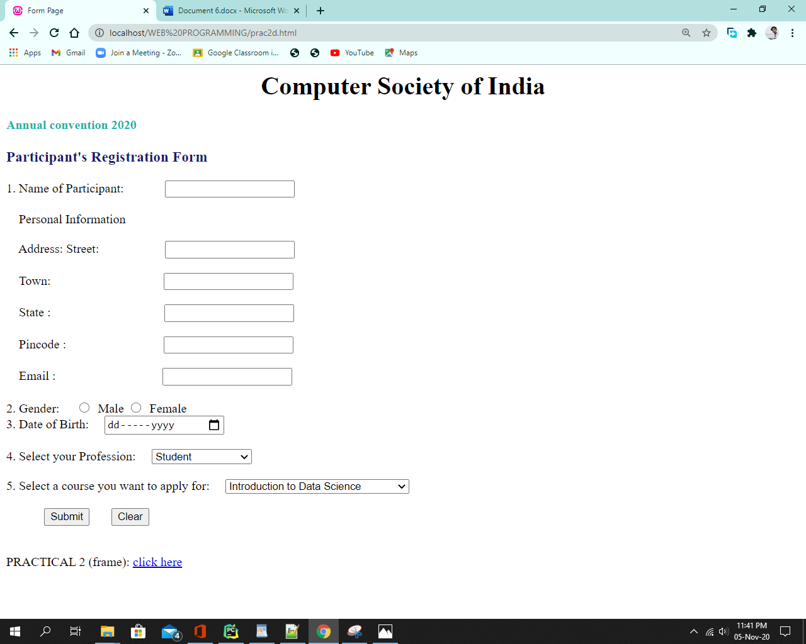

[**PRACTICAL 3**](http://pr3)

Code:

<!DOCTYPE>

<html>

<head>

<title>fit.edu.in</title>

<link rel="stylesheet" href="./assets/ExtCSS.css">

<style>

.zoom:hover {

transform: scale (1.5);

}

. zoom2: hover {

transform: scale (2);

}

h1{

background-image:url("./assets/bg9.svg");

color:limegreen;

letter-spacing:7pt;

text-align:center;

text-decoration: underline;

text-transform: uppercase;

word-spacing:2pt;

}

</style>

</head>

<body>

<center>

<h1>

<img src="./assets/shield.png" alt="" height="10%" width="5%">

FRANCIS INSTITUTE OF TECHNOLOGY

<img src="./assets/shield.png" alt="" height="10%" width="5%">

<h1>

<p>

FIT offers a wide spectrum of co-curricular, extracurricular, and athletic opportunities in addition to academics,<br>

which stands on the pillars many Student Clubs and Student Councils. The synaesthesia of sports, culture, <br>

literary and technical forums at FIT harness the creative potential of students keeping in view the tastes of <br>

the Millennial Generation that shall equip the students as successful professionals and future global leaders.

</p>

</center>

<br><br><br>

<table class="zoom" border="6px" align="center">

<tr><td rowspan="4"> <un style="list-style-type: square;"><li>COURSES</li>

<ul type="disk">

<li>B.E. or B.Tech. in Information Technology</li>

<li>B.E. or B.Tech. in Information and Communication Technology </li>

<li>B.E. or B.Tech. in Information Security </li>

<li>BCA (Bachelor of Computer Application) </li>

<li>BIT (Bachelor of Information Technology) </li>

<li> B.Sc. IT </li>

<li>Integrated (B.E./B.Tech. + M.E./MTech.) Computer Engineering</li>

<li> BBA in IT </li>

<li> BA (IT) </li>

<li>BCom. (IT) </li>

</ul>

</un>

</td></tr>

<tr></tr>

<tr></tr>

<tr></tr>

<table>

<h3>

Scan

</h3><br><br>

<img src="./assets/qr3.png" alt="" height="12%" width="8%" align="left" class="zoom2" style="margin-left:50px;">

<center class="margin">

<a href="https://www.jotform.com/form-templates/admissions-form"><img src="./assets/r2.png" alt="" height="6%" width="4%" class="zoom"> </a><br><font color="white" size="4px">Apply now <font></font><br><br>

</center>

<br><br>

<center>

<div align="center"

Follow us on <br><br> <a href="https://www.facebook.com/login/"><img src="./assets/facebook.png" alt="" height="6%" width="5%" class="zoom"></a> &ensp; &ensp;

<a href="https://www.instagram.com/?hl=en"> <img src="./assets/instagram.png" alt=""height="6%" width="5%" class="zoom"></a> &ensp; &ensp;

<a href="https://twitter.com/explore"> <img src="./assets/twitter.png" alt=""height="6%" width="5%" class="zoom" ></a> &ensp;

<br><br><br>

</div>

</center>

</body>

</html>

External CSS:

body{

background-image: url("bg7.png");

background-size: 1520px;

}

div{

color:yellow;

border-bottom: maroon outset thin;

border-left: maroon outset thin;

border-right: maroon outset thin;

border-top: maroon outset thin;

filter:shadow(color=green,direction=100);

text-align:center;

width:800px;

}

p {

color : magenta;

font-family :Algerian;

font-size : medium;

font-style:italic;

font-weight:lighter;

}

h3{

Background-color:lime;

Border-bottom:gray outset left;

Border-left: gray outset left;

Border-right:gray outset left;

Border-top:gray outset left;

color:blue;

font-family:Aarial;

position:absolute;

}

li {

color:maroon;

list-style-image:url("./assets/record.png");

Text-transform:uppercase;

font-size: 10px;

}

. margin{

margin-left: 200px;

margin-right: 200px;

}

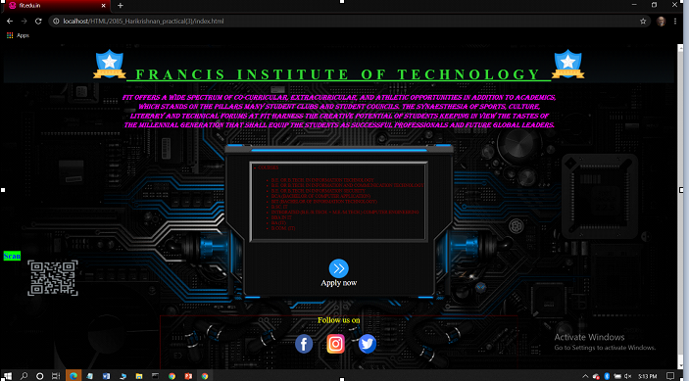

**(2)**

**Code:**

<!DOCTYPE html>

<html>

<head>

<meta http-equiv="Content-Type" content="text/html; charset=utf-8">

<title>Multiple Class Selector Example</title>

<style type="text/css" media="all">

.heading {

font-family: Impact, Sans-Serif;

}

.veryimportant {

background-color: yellow;

}

.stuff {

color: red;

}

.veryimportant.stuff {

font-style: italic;

}

.veryimportant.example.stuff {

text-decoration: underline;

}

</style>

</head>

<h1 class="veryimportant heading stuff">Heading (yellow background, red text, italic, and Impact)</h1>

<p class="veryimportant">This is the first paragraph. (yellow background, black text)</p>

<p class="stuff">This is the second paragraph. (red text, default background)</p>

<p class="veryimportant stuff">This is the third paragraph. (yellow background, red text, italic)</p>

<p class="stuff veryimportant example dummy">This is the fourth paragraph. (yellow background, red text, italic, underlined)</p>

</body>

</html>

**Output:**

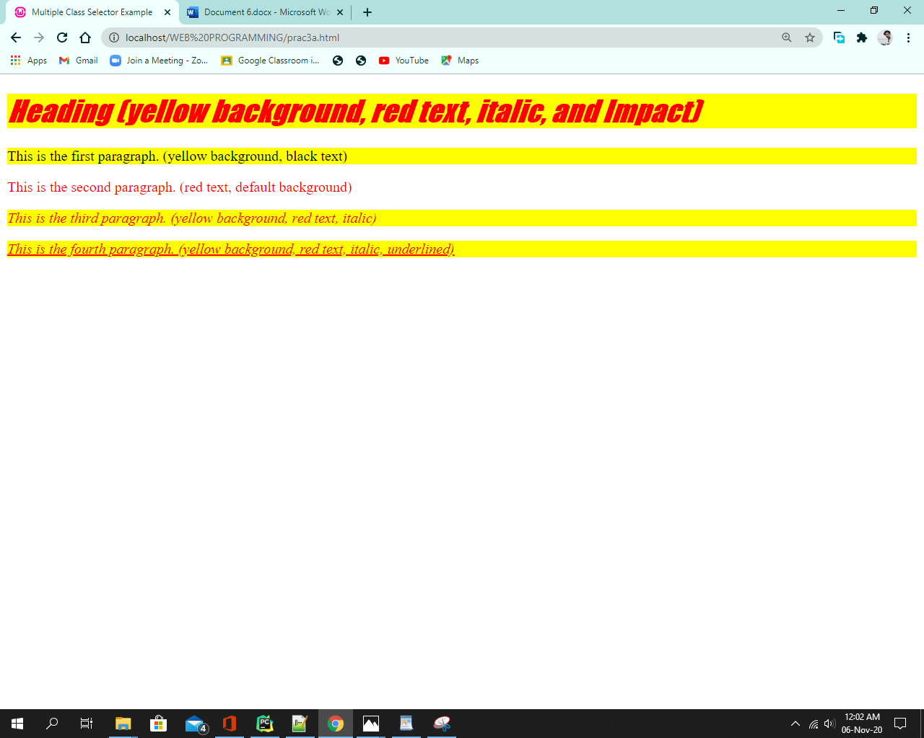

[**PRACTICAL 4**](http://pr4)

a. Performing various mathematical operations such as calculating factorial / finding Fibonacci Series / Displaying Prime Numbers in a given range / Evaluating Expressions / Calculating reverse of a number

b. Validating the various Form Elements

Code :

<html>

<head>

<title> TABLE </title>

<script language ="javascript">

<!--Factorial-->

<!--

function fact()

{

var n,i,sum=1;

n=parseInt(prompt("Enter n"));

for(i=n;i>0;i--)

{

sum=sum*i;

}

document.writeln("Factorial is="+sum);

}

-->

/*/ Fibonacci/*/

<!--

function fib()

{

var var1=0;var var2=1;var var3;

var num=prompt("Enter the limit for series: ",0);

document.write("The fibonacci series upto "+num+" terms are :<br/>")

document.write(var1+"<br/>");

document.write(var2+"<br/>");

for(var i=3;i<num;i++)

{

var3=var1+var2;

var1=var2;

var2=var3;

document.write(var3+"<br/>");

}

}

-->

<!--Expression-->

<!--

function expreval()

{

var expr, result;

expr=prompt("Enter the expression to evaluate");

result=eval(expr);

document.writeln("the result is="+result);

}

-->

</script>

</head>

<br>

<br>

<body bgcolor="DodgerBlue" align="center">

<!--Factorial-->

<h1>Factorial </h1>

<form name="frm1">

<input type=button name=btnchk value="Calculate" onclick="fact();">

</form>

<!--Fibonacci-->

<h1> Fibonacci</h1>

<form name="frm1">

<Input type = button name=btnchk value = Calculate onclick="fib();">

</form>

<!--Expression-->

<h1>The expression to evaluate</h1>

<form name="frm1">

<input type=button name=btnchk value="Calculate" onclick="expreval();">

</form>

<!--Prime-->

<h1>Display prime number</h1>

<form name="frm1">

<a href="prime.html">

<input type=button name=btnchk value="Calculate" >

</a>

</form>

<!--Prime-->

<h1>Reverse of a number</h1>

<form name="frm1">

<a href="rev.html">

<input type=button name=btnchk value="Calculate" >

</a>

</form>

</body>

</html>

Prime no

<html>

<head>

<title>Prime No</title>

</head>

<body bgcolor="DodgerBlue" align="center">

<br><br><br>

<h1 style="color:black"><u>PRIME NUMBERS</u></h1>

<FORM onsubmit="prime()">

Starting number:<br>

<input type="number" name="f_number"

id="first"><br><br>

Last Number:<br>

<input type="number" name="l_number" id="last"><br><br>

<input type="submit" value="OUTPUT">

</FORM>

<script type="text/javascript">

function prime(){

var first=document.getElementById("first").value;

var last=document.getElementById("last").value;

var i,j,isPrime;

if(first<2){

first=2;

}

for(i=first;i<=last;i++){

isPrime=1;

for(j=2;j<=i/2;j++)

{

if(i%j==0){

isPrime=0;

break;

}

}

if(isPrime==1){

document.write(i + "<br>");

}

}

}</script>

</body>

</html>

Reverse

<!DOCTYPE html>

<html>

<head>

<title>Reverse_of_a_Number</title>

<style>

form{

text-align: center;}

input{padding: 8px;}

#result{color:rgb(156, 9, 4);text-align: center;font-size:20px;}

h1{text-align: center;margin: 50px auto;font-size:

20px;}

</style>

</head>

<body bgcolor="DodgerBlue">

<br><br>

<h1 style="color:black">REVERSE OF A NUMBER </h1>

<form id="form">

<input type="text" name="" id="number">

<input type="submit" value="CHECK">

</form>

<p id="result"></p>

<script type="text/javascript">

var frm=document.getElementById("form");

frm.onsubmit=function(){

var user=document.getElementById("number").value;

var preview=document.getElementById("result");

var i,rev=0;

while(user !=0){

rev=(rev*10)+(user%10);

user=parseInt(user/10);

}

preview.innerHTML=" Reverse of the Number is = " + rev;

return false;

}

</script>

</body>

</html>

**Output:**

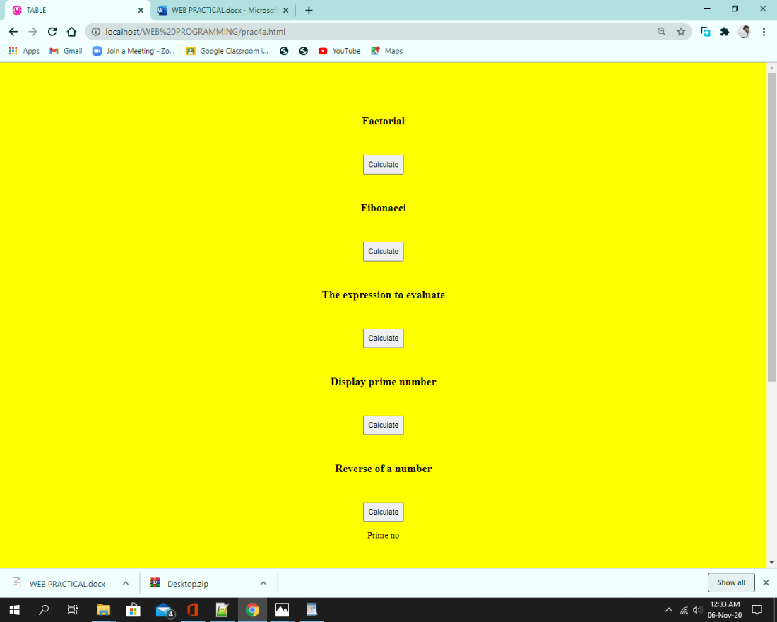

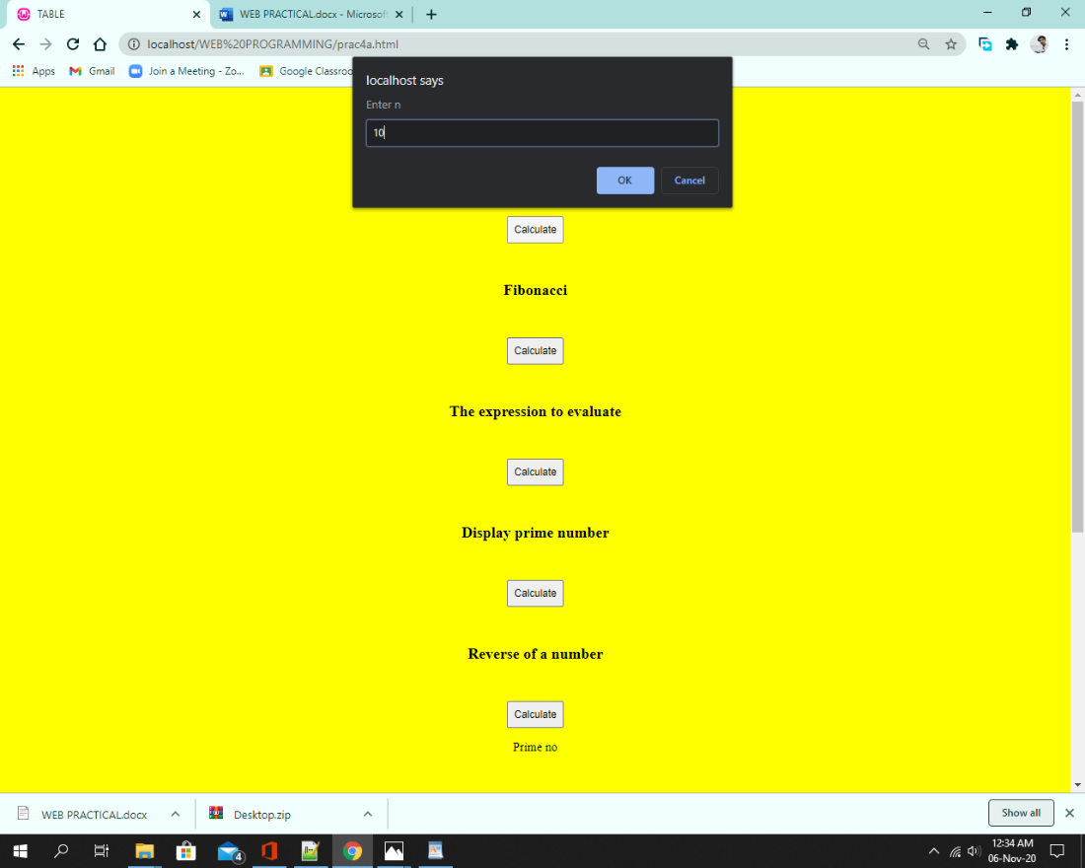

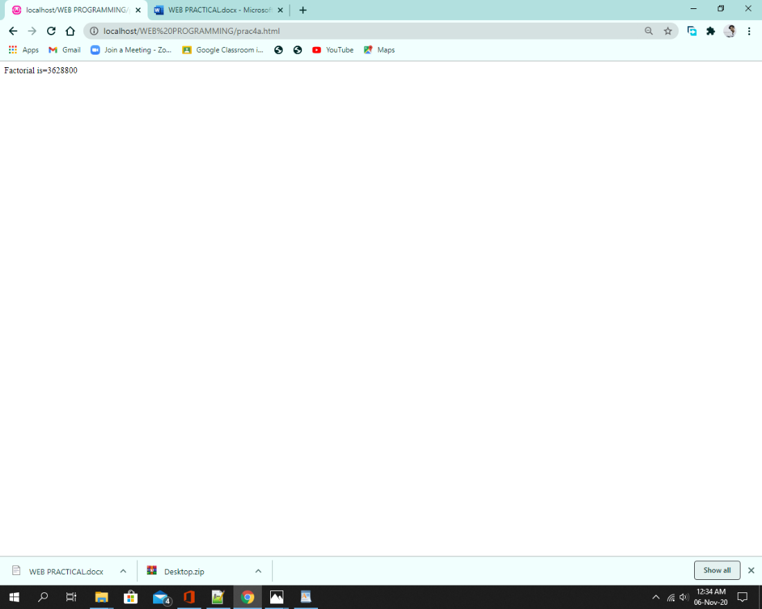

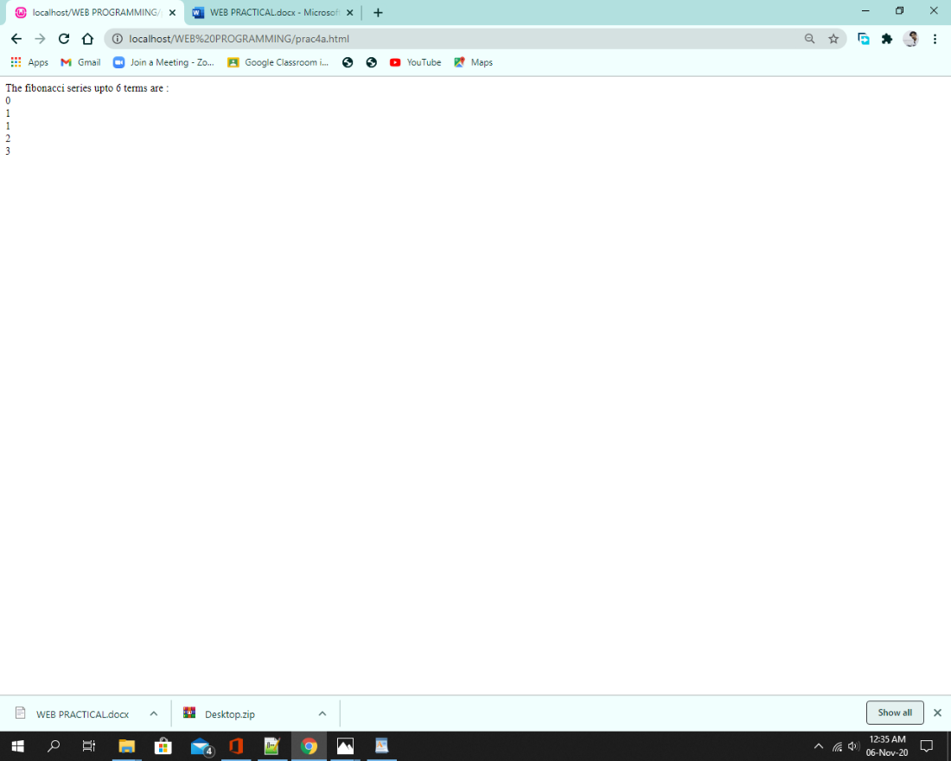

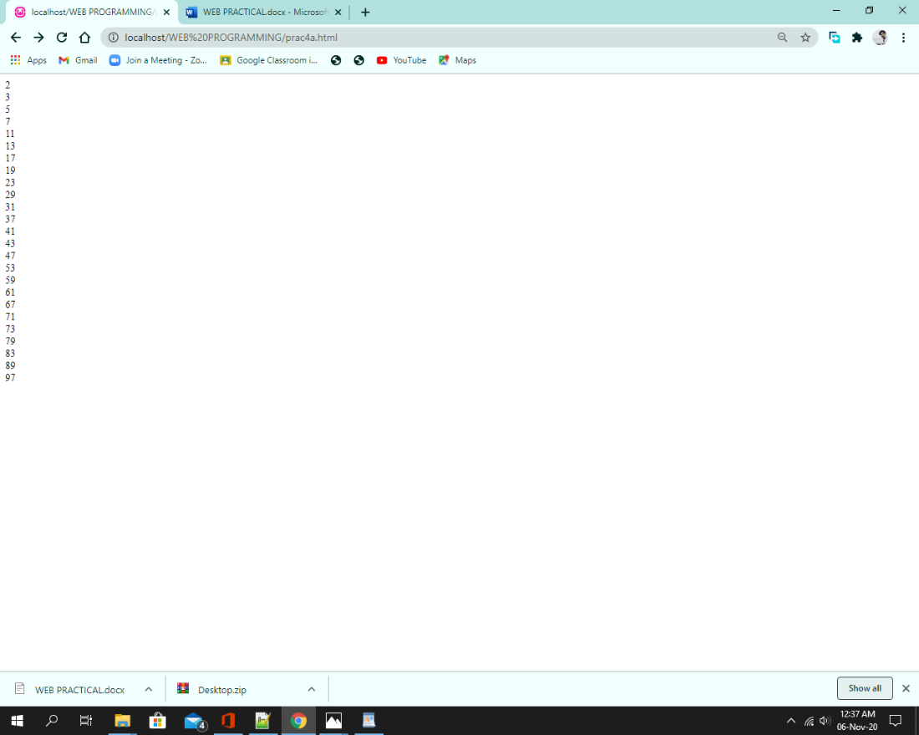



b. Validating the various Form Elements

Code :

<html>

<head>

<title>Homepage </title>

<script>

function isage()

{

var s;

s=document.form1.txtage.value;

if (isNaN(s)==true)

{

alert("enter age in number");

document.form1.txtage.select();

}

}

function validateEmail()

{

var s,apos,dpos;

s=document.form1.txtemail.value;

apos=s.indexOf("@");

dpos=s.lastIndexOf(".");

if(apos<=0||dpos<=0||dpos-apos<=2)

{

alert("Invalid email");

document.form1.txtemail.focus();

}

}

function validateblank()

{

var n,s=0;

for(i=0;i<=3;i++)

{

s=document.forms1[0].element[i].value;

n=s.length;

if(n<=0)

{

alert(document.forms[0].element[i].name+"not filled");

document.forms1[0].elements[i].select();

}

}

}

</script>

</head>

<body bgcolor="yellow" align="center"><br><br>

<h1>REGISTRATION</h1>

<form name="form1">

<p>NAME:<input type="text" name="txtname" onblur="validateblank();"></p>

<p>AGE:<input type="text" name="taiga" onblur="isage()"></p>

<p>EMAIL:<input type="text" name="txtemail" onblur="validateEmail();"></p>

<p>Address:<input type="text" name="txtaddress" ><br><br>

<input type="submit" name="submit" value ="SUBMIT" onclick="validateblank();">

</form>

</body>

</html>

**Output:**

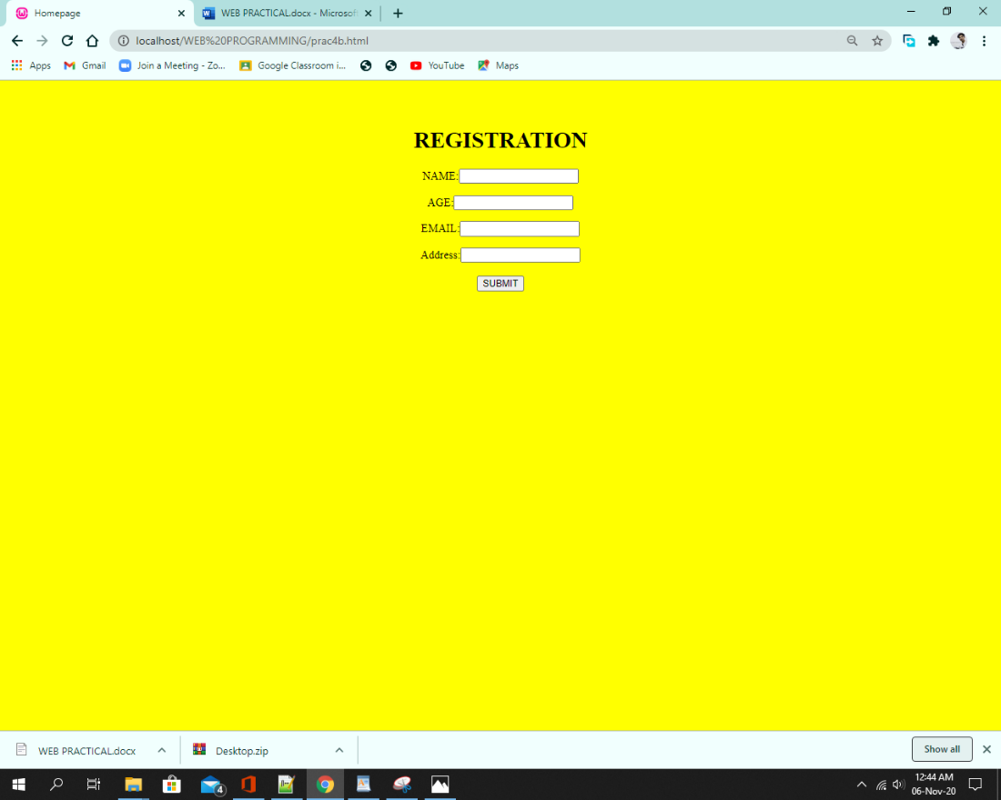

[**Practical : 5**](http://pr5)

**String :**

<!DOCTYPE html>

<html>

<body bgcolor="yellow">

<h2>JavaScript String Properties</h2>

<p>The length property returns the length of a string:</p>

<p id="demo"></p>

<script>

var txt = "ABCDEFGHIJKLMNOPQRSTUVWXYZ";

var len = txt.length;

var str = "Please locate where 'locate' occurs!";

var pos = str.indexOf("locate");

var str = "Please locate where 'locate' occurs!";

var poslast = str.lastIndexOf("locate");

document.getElementById("demo").innerHTML = "The length is "+ len+"<br>The index Of- locate is "+ pos+"<br>Last IndexOf locate is "+poslast;

</script>

</body>

</html>

**Output:**

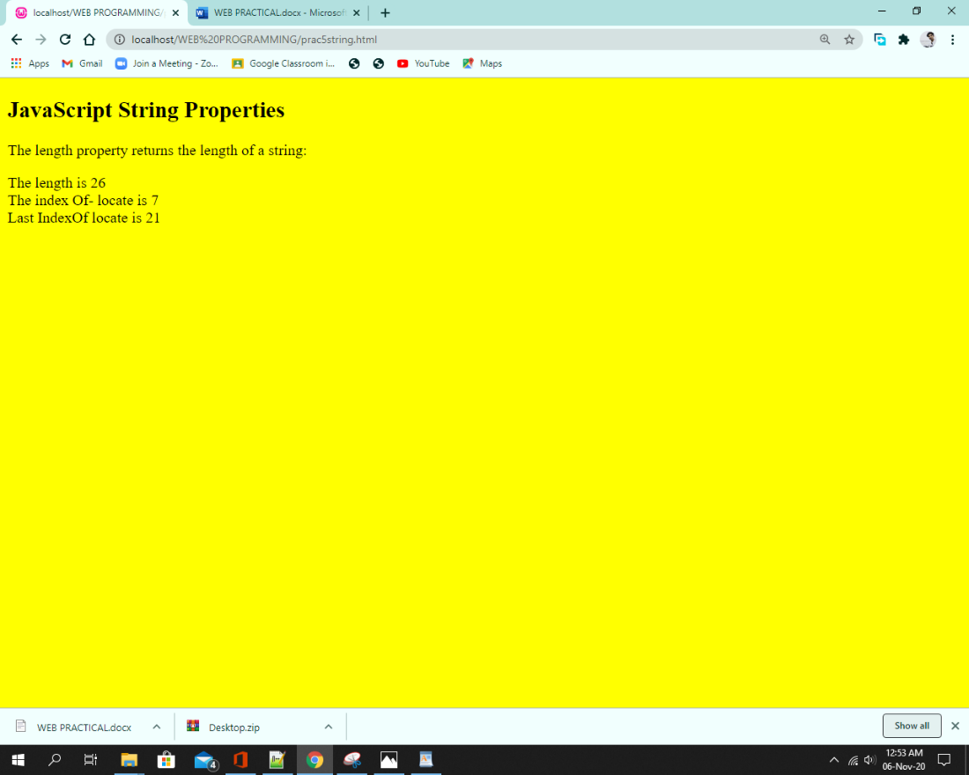

Regular expression :

Code :

<!DOCTYPE html>

<html>

<body bgcolor="yellow">

<script LANGUAGE="JavaScript">

var objRegExp = /(\w+)\s(\w+)/;

var strFullName = 'HARIKRISHNAN SATHYAN';

var strReverseName = strFullName.replace(objRegExp, '$2 $1');

document.write('Your original name: '+strFullName+'<br><br>')

document.write('Your name reversed: '+strReverseName)

</script>

</body>

</html>

**Output:**

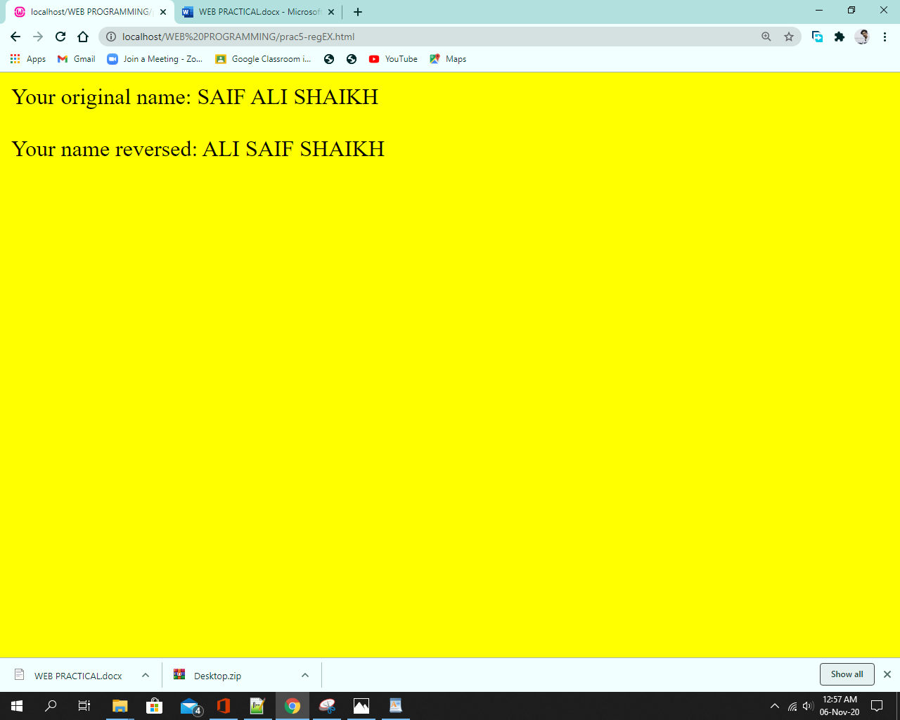

Math:

Code:

<html>

<body>

<h2 Style="yellow">JavaScript Math</h2>

<p>The value of PI using Math is:</p>

<p id="mat"></p>

<script>

document.getElementById("mat").innerHTML = Math.PI;

document.write("The square root of 64 using Math:")

document.write("<br />");

document.write(Math.sqrt(64));

</script>

</body>

</html>

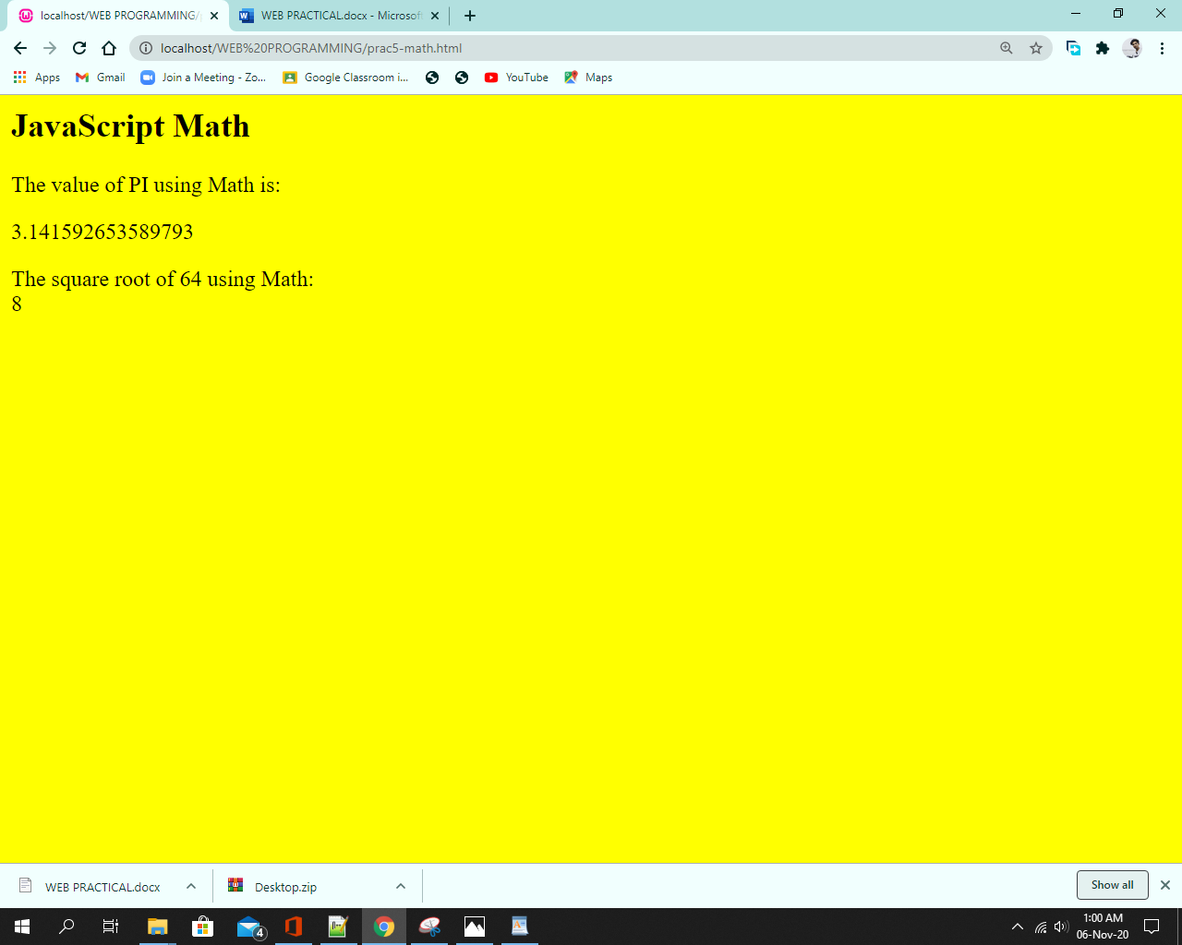

Hist:

Code:

<Html>

<Head> <Title>Demonstration of window, location and history object</Title>

<Script language=JavaScript>

function forward()

{

self.history.forward();

}

function back()

{

self.history.back();

}

function new1()

{window.location=document.frm1.txtFile.value;

ALERT(document.frm1.txtFile.value);

}

function go()

{

if(document.frm1.txtFile.value=="")

{

window.alert("Enter The Location To Go");

return false;

}

window.location=document.frm1.txtFile.value;

}

</Script>

</Head>

<Form name=frm1>

Location: <input type=file name=txtFile> <br><br>

<input type=Button value="Go" onClick=go(); >

<input type=Button value="Next" onClick=forward();>

<input type=Button value="Previous" onClick=back();>

<input type=Button value="Open New" onClick=new1();>

</Form>

</Html>

**Output**:

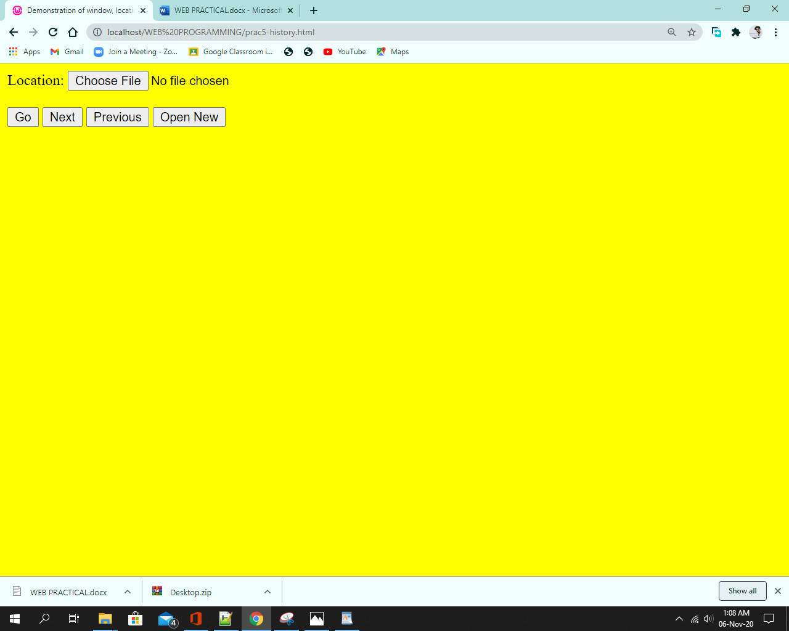

Date:

Code :

<!DOCTYPE html>

<html>

<body bgcolor="yellow">

<p>The internal clock in JavaScript starts at midnight January 1, 1970.</p>

<p>The getTime() function returns the number of milliseconds since then:</p>

<p id="Time"></p>

<p id="fullyear"></p>

<p id="day"></p>

<p id="ADDday"></p>

<script>

var d = new Date();

document.getElementById("Time").innerHTML = 'Total milliseconds since midnight January 1, 1970: '+d.getTime();

document.getElementById("fullyear").innerHTML = 'Current Year: '+d.getFullYear();

document.getElementById("day").innerHTML = 'Current Day: '+d.getDay();

var newday = new Date();

newday.setDate(newday.getDate() + 50);

document.getElementById("ADDday").innerHTML = newday;

</script>

</body>

</html>

**Output:**

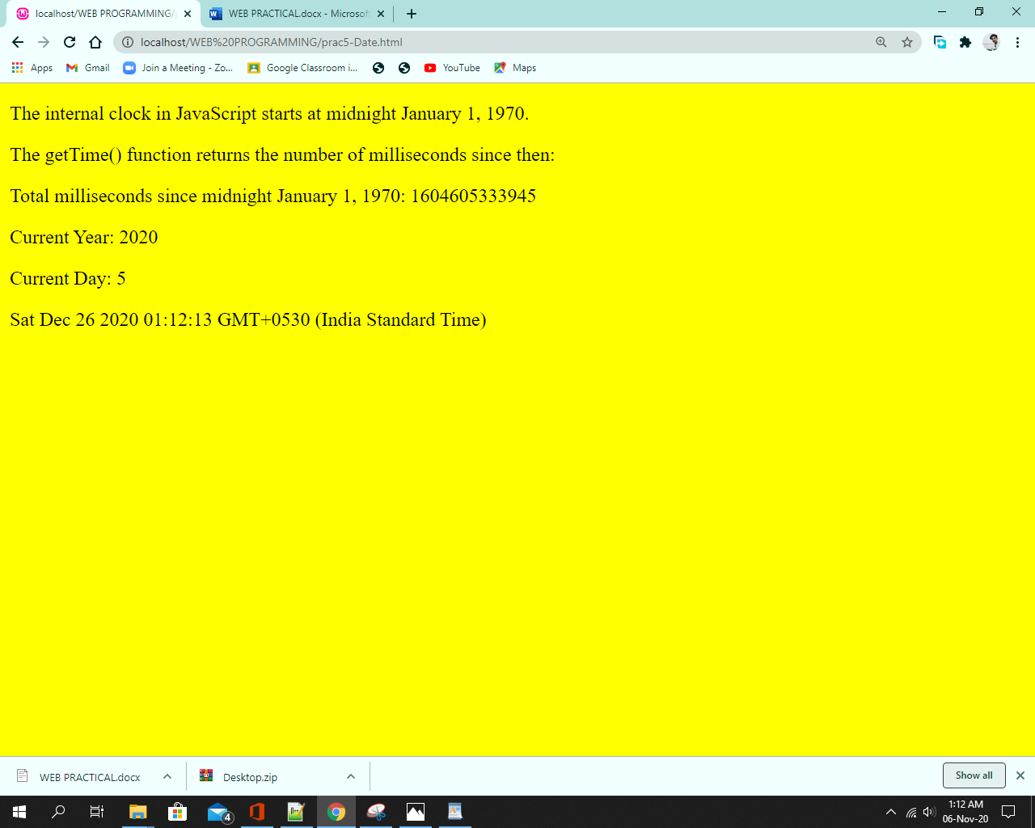

(b)

Navigator:

Code :

<!DOCTYPE html>

<html>

<body bgcolor="yellow">

<h2>JavaScript Navigator</h2>

<p id="demo"></p>

<script>

document.getElementById("demo").innerHTML += "Navigator.appCodeName is " + navigator.appCodeName+"<br><br>";

document.getElementById("demo").innerHTML += "Navigator.appVersion is " + navigator.appVersion+"<br><br>";

document.getElementById("demo").innerHTML += "Navigator.platform is " + navigator.platform+"<br><br>";

</script>

</body>

</html>

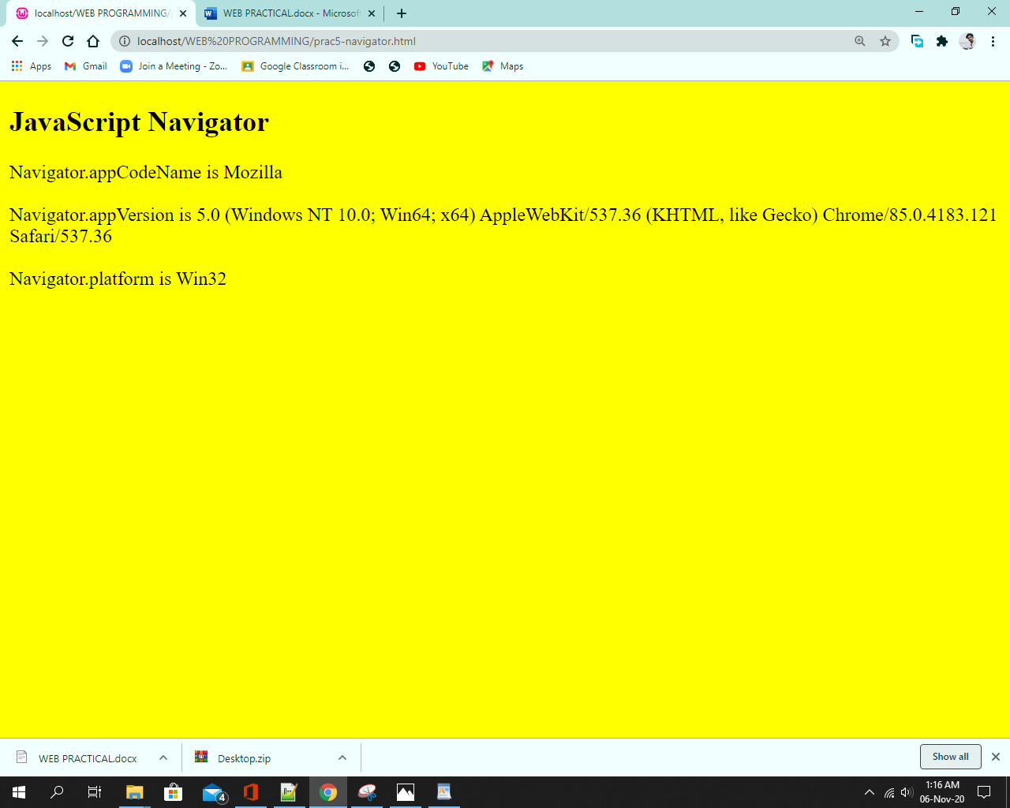

Window :

Code:

<!DOCTYPE html>

<html>

<head>

<script>

function openWin()

{

window.open("https://www.tcsc.edu.in/","_blank","toolbar=yes, location=yes, directories=no, status=no, menubar=yes, scrollbars=yes, resizable=no, copyhistory=yes, width=400, height=400");

}

function blurWin()

{

myWindow.blur();

}

function focusWin()

{

myWindow.focus();

}

</script>

</head>

<body align="center" bgcolor="yellow">

<form>

<p>To Open a new Window: <br><br><input type="button" value="Open new window" onclick="openWin()"><br><br></p>

<p>To Close the newly opened Window: <br><br><input type="button" value="Blur new window" onclick="blurWin()"><br><br></p>

<p>To Blur the newly opened Window: <br><br><input type="button" value="Focus new window" onclick="focusWin()"><br><br></p>

</form>

</body>

</html>

**Output:**

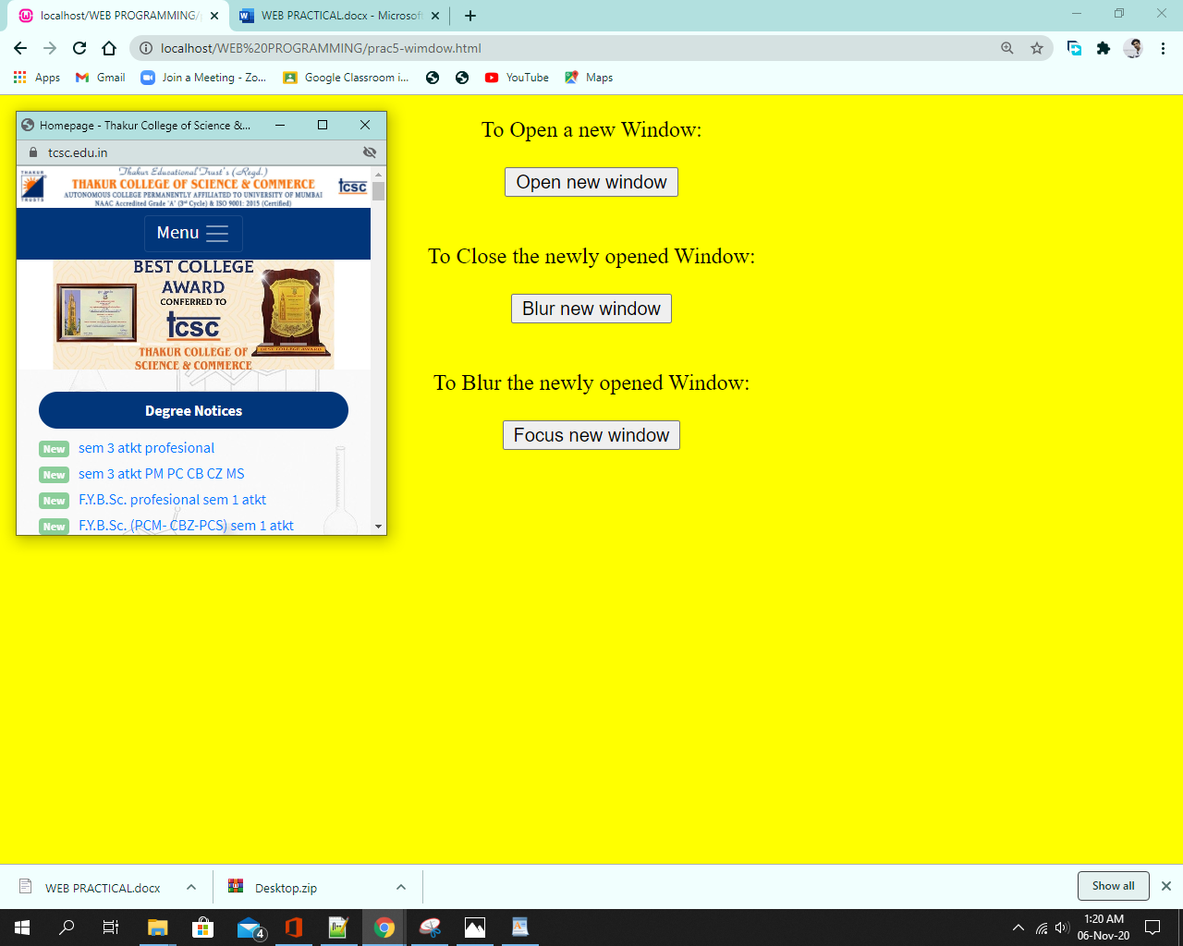

**Cookies:**

Code:

<!DOCTYPE html>

<html>

<head>

<script>

function setCookie(cname,cvalue,exdays) {

var d = new Date();

d.setTime(d.getTime() + (exdays*24*60*60*1000));

var expires = "expires=" + d.toGMTString();

document.cookie = cname + "=" + cvalue + ";" + expires + ";path=/";

}

function getCookie(cname) {

var name = cname + "=";

var decodedCookie = decodeURIComponent(document.cookie);

var ca = decodedCookie.split(';');

for(var i = 0; i < ca.length; i++) {

var c = ca[i];

while (c.charAt(0) == ' ') {

c = c.substring(1);

}

if (c.indexOf(name) == 0) {

return c.substring(name.length, c.length);

}

}

return "";

}

function checkCookie() {

var user=getCookie("username");

if (user != "") {

alert("Welcome again " + user);

} else {

user = prompt("Please enter your name:","");

if (user != "" && user != null) {

setCookie("username", user, 30);

}

}

}

</script>

</head>

<body onload="checkCookie()"></body>

</html>

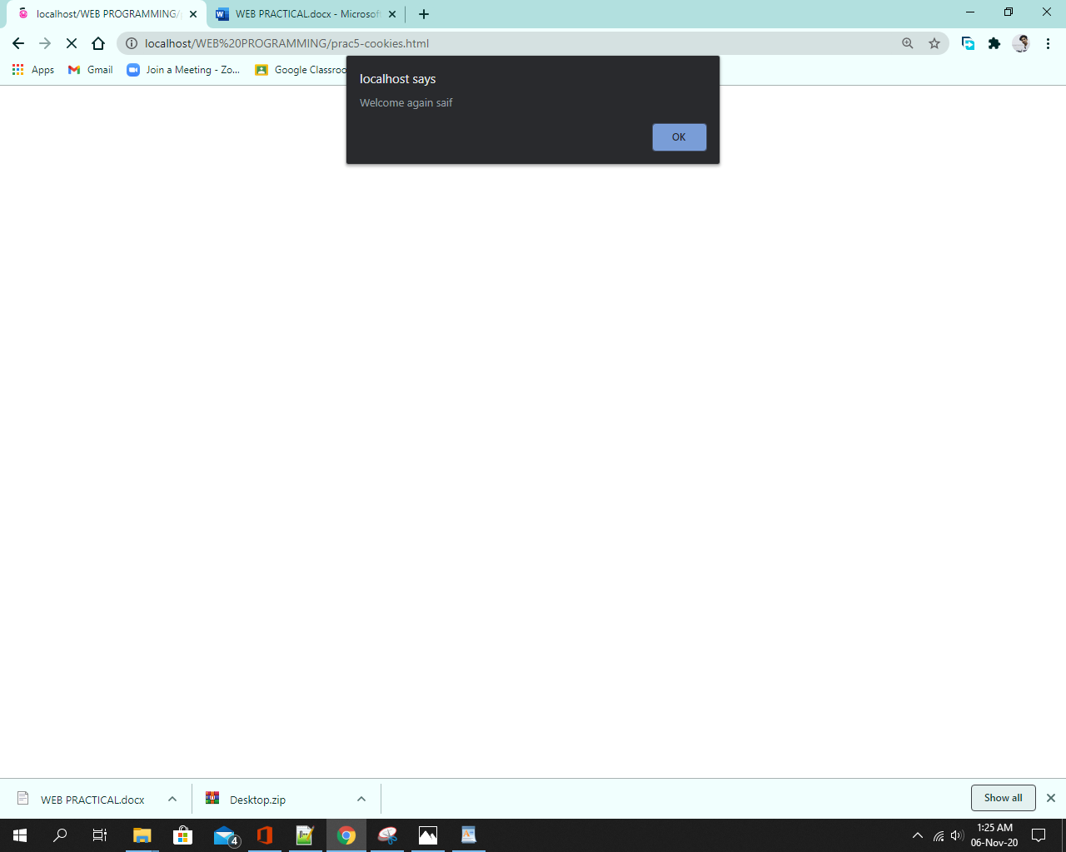

[**PRACTIACL 6**](http://pr6)

6. Create a XML file with Internal / External DTD and display it using

a. CSS b. XSL

<?xml version="1.0" encoding ="UTF-8"?>

<xsl:stylesheet version="1.0" xmlns:xsl="http://www.w3.org/1999/XSL/Transform">

<xsl:template match="Authorname">

<xsl:value-of select="firstname"/>

<xsl:value-of select="lastname"/>

<xsl:if test="position()!=last()">,</xsl:if>

</xsl:template>

<xsl:template match="/">

<html>

<head>

<title>Book info</title>

</head>

<body>

<table border ="1">

<thead>

<th>Book ID </th>

<th>Book name</th>

<th>Author name</th>

<th>Price</th>

</thead>

<tbody>

<xsl:for-each select="Bookinfo/Book">

<xsl:sort select="Price" data-type="number" order = "descending"/>

<tr>

<td><xsl:value-of select ="@Bookid"/></td>

<td><xsl:value-of select ="Bookname"/></td>

<td><xsl:apply-templates select ="Authorname"/></td>

<td>

<font color="red">

<xsl:apply-templates select="Price"/>

</font>

<br/>

</td>

</tr>

</xsl:for-each>

</tbody>

</table>

</body>

</html>

</xsl:template>

</xsl:stylesheet>

XML:-

<?xml version="1.0"?>

<!DOCTYPE Bookinfo SYSTEM "Book.dtd">

<?xml-stylesheet type="text/xsl" href="Book1.xsl"?>

<Bookinfo>

<Book Bookid="001">

<Bookname>Automata Theory</Bookname>

<Authorname>

<firstname>John</firstname>

<lastname>Hopcroft</lastname>

</Authorname>

<Price>499</Price>

</Book>

<Book Bookid="002">

<Bookname>Data Structures and Algorithms</Bookname>

<Authorname>

<firstname>Narasimha</firstname>

<lastname>Karumanchi</lastname>

</Authorname>

<Price>650</Price>

</Book>

<Book Bookid="003">

<Bookname>Python for Data Analysis</Bookname>

<Authorname>

<firstname>Wes</firstname>

<lastname>McKinney</lastname>

</Authorname>

<Price>1450</Price>

</Book>

<Book Bookid="004">

<Bookname>Introduction to Algorithms</Bookname>

<Authorname>

<firstname>Thomas</firstname>

<lastname>Cormen</lastname>

</Authorname>

<Price>2195</Price>

</Book>

</Bookinfo>

**Output:**

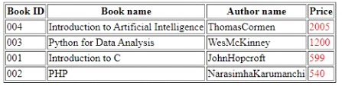

B)Using CSS:-

Code:-

<?xml version="1.0" standalone="yes"?>

<?DOCTYPE persons[

<!ELEMENT person (surname,hobby,intrest,activity?)>

<!ATTLIST person year(1989/1990/1991) "1990">

<!ATTLIST person id(10/11/12/13) "12">

<!ATTLIST person name(Ramesh/Suresh/) >

<!ELEMENT surname(#PCDATA)>

<!ELEMENT hobby(#PCDATA)>

<!ELEMENT intrest(#PCDATA)>

<!ELEMENT activity(#PCDATA)]?>

<?xml-stylesheet href ="hobby.css" type="text/css"?>

<persons>

<person year="1990" id="10" name="Ramesh">

<surname>Sharma</surname>

<hobby>Reading</hobby>

<intrest>Singing</intrest>

<activity>Web designing</activity>

</person>

<person year="1990" id="10" name="Suresh">

<surname>Singh</surname>

<hobby>Swimming</hobby>

<intrest>painting</intrest>

<activity>Java</activity>

</person>

</persons>

CSS:

<style type="text">

persons{display:block}

person{display:block}

intrest{ color:blue }

hobby{ color:green }

activity{color:purple}

surname{color:red}

</style>

**Output:**

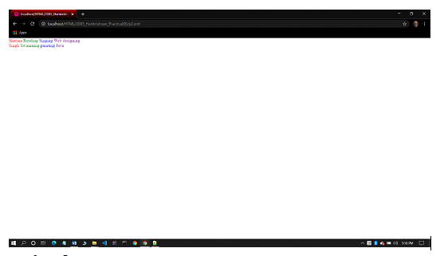

[**Practical 7**](http://pr7)

1. Design a webpage to handle asynchronous requests using AJAX on

⦁ Mouseover

⦁ button click

<html>

<head>

<title>Working AJAX Program</title>

<script language="JavaScript">

var XMLHttpRequestObject=false;

if(window.XMLHttpRequest)

{

XMLHttpRequestObject=new XMLHttpRequest();

}

else if(window.ActiveXObject)

{

XMLHttpRequestObject=new ActiveXObject("Microsoft.XMLHTTP");

}

function getData(dataSource,divID)

{

if(XMLHttpRequestObject)

{

var obj=document.getElementById(divID);

XMLHttpRequestObject.open("GET", dataSource);

XMLHttpRequestObject.onreadystatechange=function()

{

if (XMLHttpRequestObject.readyState==4 && XMLHttpRequestObject.status==200)

{

obj.innerHTML=XMLHttpRequestObject.responseText;

}

}

XMLHttpRequestObject.send(null);

}

}

</script>

</head>

<body align="center">

<h1>Interactive Mouseover</h1>

<hr><br>

<img src="m1.jpg" onmouseover="getData('m1.txt','targetDiv')" height=210 width=130> &ensp; &ensp; &ensp; &ensp;

<img src="m2.jpg" onmouseover="getData('m2.txt','targetDiv')" height=210 width=130> &ensp; &ensp; &ensp; &ensp;

<img src="m3.jpg" onmouseover="getData('m3.txt','targetDiv')" height=210 width=130> &ensp; &ensp; &ensp; &ensp;

<img src="m4.jpg" onmouseover="getData('m4.txt','targetDiv')" height=210 width=130>

<br><br><hr>

<h1>

<div id="targetDiv">

<p>Display Message Here</p>

</div>

</h1>

</body>

</html>

**Output:**

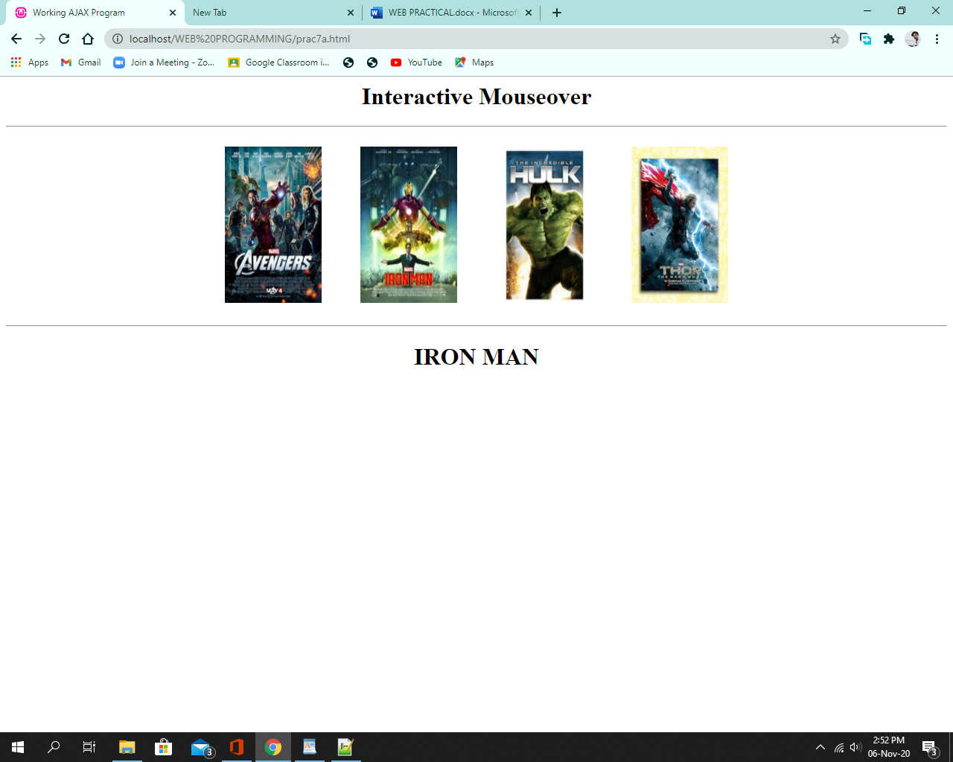

**Code:**

<html>

<head>

<title>Ajax At Work</title>

<script language="javascript">

var XMLHttpRequestObject = false;

if(window.XMLHttpRequest)

{

XMLHttpRequestObject = new XMLHttpRequest();

}

else if(window.ActiveXObject)

{

XMLHttpRequestObject = new ActiveXObject("Microsoft.XMLHTTP");

}

function getData(dataSource,divID)

{

if(XMLHttpRequestObject)

{

var obj = document.getElementById(divID);

XMLHttpRequestObject.open("GET",dataSource);

XMLHttpRequestObject.onreadystatechange=function()

{

if(XMLHttpRequestObject.readyState ==4 && XMLHttpRequestObject.status ==200)

{

obj.innerHTML = XMLHttpRequestObject.responseText;

}

}

XMLHttpRequestObject.send(null);

}

}

</script>

</head>

<body align="center" bgcolor="yellow">

<br><br>

<h1>Fetching data with Ajax</h1><br>

click here to generate your secret vouter code

<form><br>

<input type="button" value="Voucher code" onclick="getData('data.txt','targetDiv')">

</form>

<table border="1" align="center" cellpadding=5 >

<tr><td>

<div id="targetDiv" >

</div>

</td>

</tr>

</table>

</body>

</html>

**Output:**

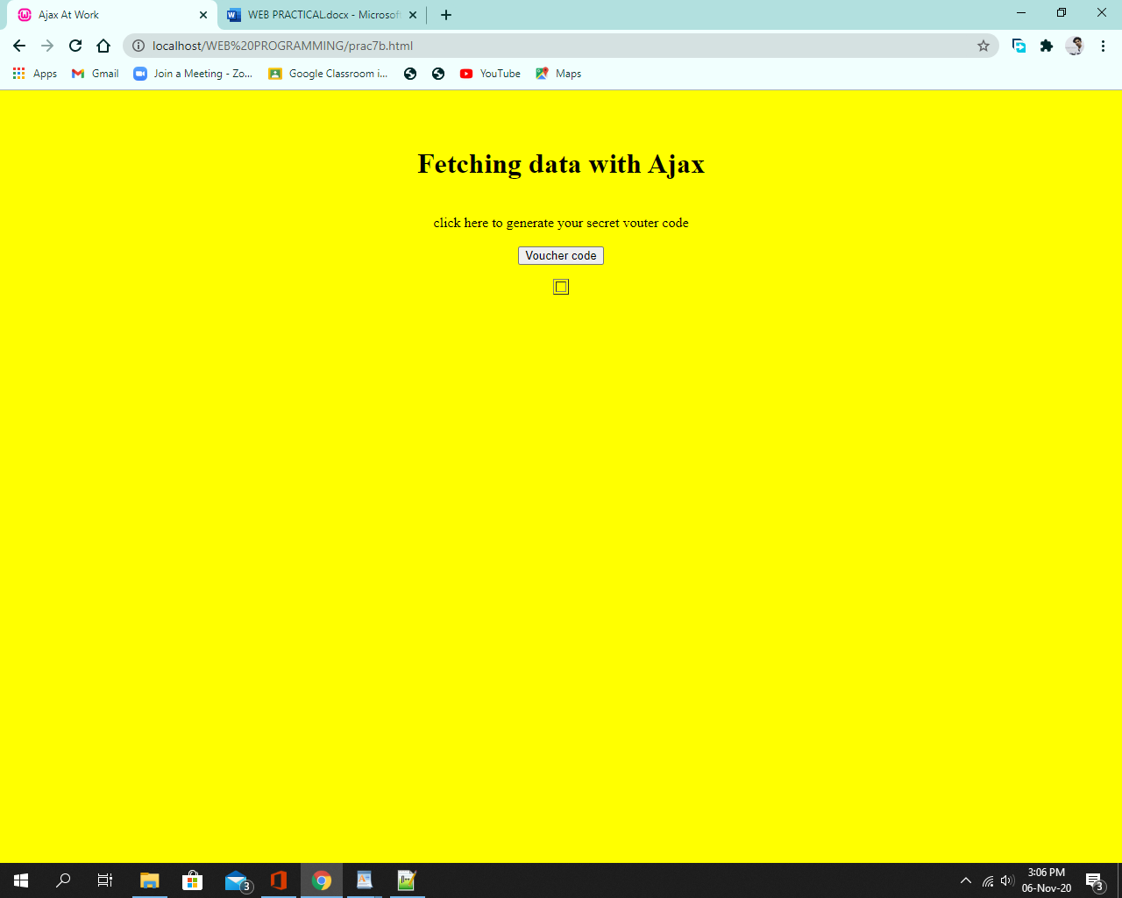

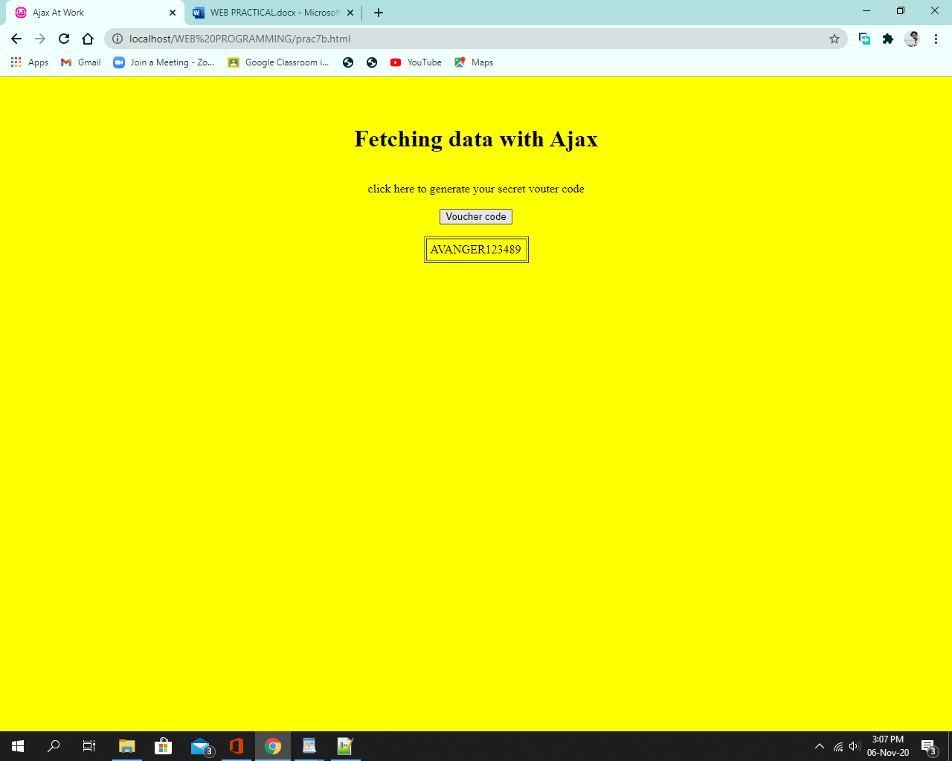

[**Practical 8**](http://pr8)

8. Write PHP scripts for

a. Retrieving data from HTML forms

b. Performing certain mathematical operations such as calculating factorial / finding Fibonacci Series / Displaying Prime Numbers in a given range / Evaluating Expressions / Calculating reverse of a number

c. Working with Arrays

d. Working with Files (Reading / Writing)

**Code:(a)**

Code:

<!DOCTYPE html>

<html>

<body bgcolor="yellow">

<br><br>

<form action="prac8aphpFile.php" method="post" align = "center">

<h1>Form with PHP</h1>

Name: <input type="text" name="name"><br><br>

E-mail: <input type="text" name="email"><br><br>

Roll No: <input type="text" name="roll"><br><br>

<input type="submit">

</form>

</body>

</html>

Php file:

<!DOCTYPE html>

<html>

<body bgcolor="yellow">

<br><br>

Welcome <?php echo $_POST["name"]; ?><br>

Your email address is: <?php echo $_POST["email"]; ?><br>

Your Roll Number is: <?php echo $_POST["roll"]; ?><br>

<?php

$t = $_POST["roll"];

if ($t > 2000 && $t < 2100)

{

echo "Your Division is: A";

}

else

{

echo "Your Division is: B";

}

?>

</body>

</html>

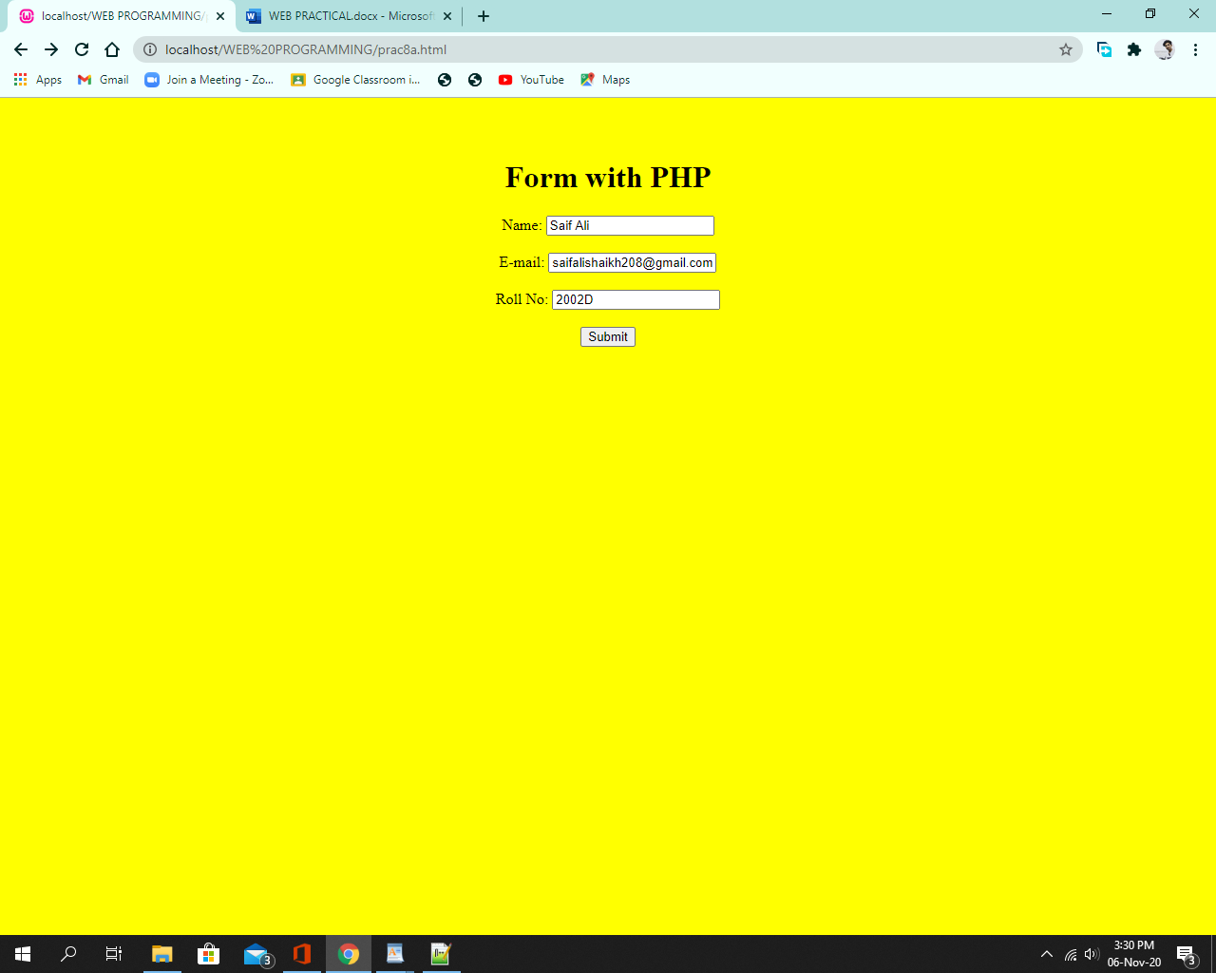

**(b)**

Code:

<!DOCTYPE html>

<html>

<body bgcolor="yellow" >

<form action="fact.php" method="post">

<h1>Factorial of a Number</h1>

Enter a range number: <input type="text" name="num">

<input type="submit">

</form>

<hr>

<form action="fibo.php" method="post">

<h1>Fibonacci Series</h1>

Enter a range number: <input type="text" name="num">

<input type="submit">

</form>

<hr>

<form action="prime1.php" method="post">

<h1>Prime Number in Given Range</h1>

Enter a range number: <input type="text" name="num">

<input type="submit">

</form>

<hr>

<form action="eval1.php" method="post">

<h1>Evaluating Expressions</h1>

Enter First Name: <input type="text" name="name1"><br><br>

Enter Last Name: <input type="text" name="name2"> &ensp; &ensp;

<input type="submit" name="Add">

</form>

<hr>

<form action="reverse.php" method="post">

<h1>Reverse of a Number</h1>

Enter a number: <input type="text" name="num"> &ensp; &ensp; &ensp;

<input type="submit">

</form>

</body>

</html>

Php Code:

Factorial:

<?php

$n = $_POST["num"];

$fact = 1;

for($i=1;$i<=$n-1;$i++)

{

$fact*=($i+1);

}

echo "The factorial of $n = $fact"."\n";

?>

Fibonacci:

<?php

// PHP code to get the Fibonacci series

function Fibonacci($n){

$num1 = 0;

$num2 = 1;

$counter = 0;

while ($counter < $n){

echo ' '.$num1;

$num3 = $num2 + $num1;

$num1 = $num2;

$num2 = $num3;

$counter = $counter + 1;

}

}

// Driver Code

$n = 10;

Fibonacci($n);

?>

Prime:

<?php

$n = $_POST["num"];;

$count = 0;

echo "The Prime Number in Given Range: "."\n\n";

for($i=2;$i<=$n;$i++)

{

$count=0;

for($j=1;$j<=$i;$j++)

{

if($i%$j==0)

{

$count=$count+1;

}

}

if($count<=2)

{

echo $i."\n";

}

}

?>

Evaluate :

<?php

$n1 = $_POST["name1"];

$n2 = $_POST["name2"];

$add = "Welcome to this page $n1 $n2";

eval("\$add = \"$add\";");

echo $add;

?>

Reverse :

<?php

$num1 = $_POST["num"];

$revnum = 0;

echo "Reverse of $num1 is : ";

while($num1 != 0)

{

$revnum = $revnum * 10 + $num1 %10;

$num1 = (int)($num1 / 10);

}

echo $revnum;

?>

**Output:**

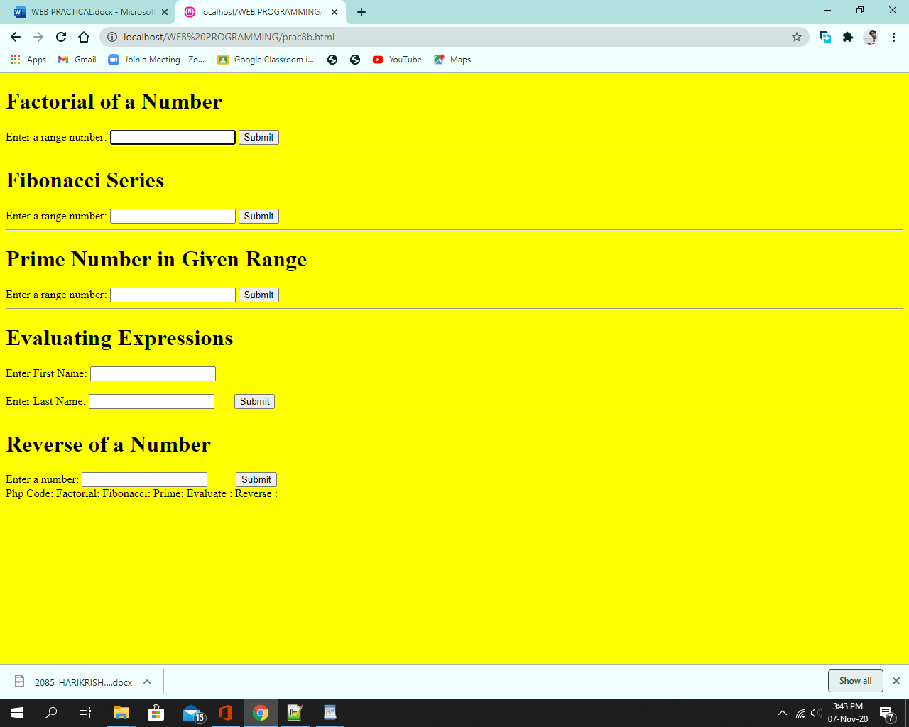

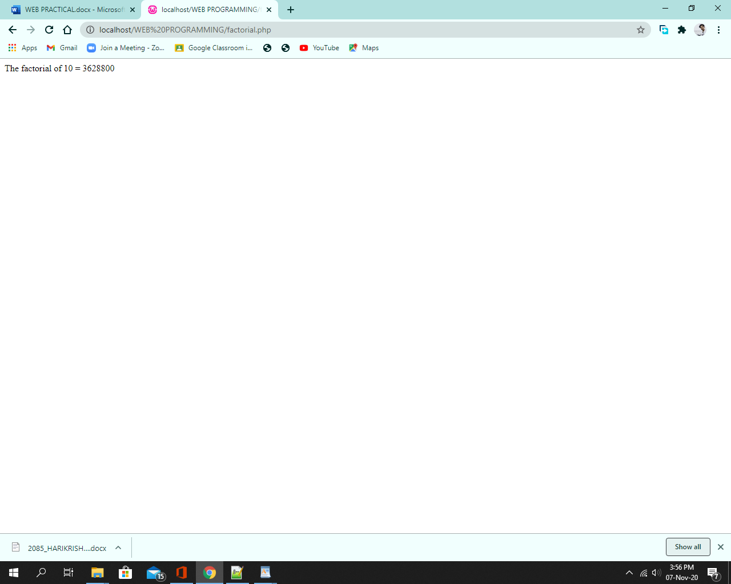

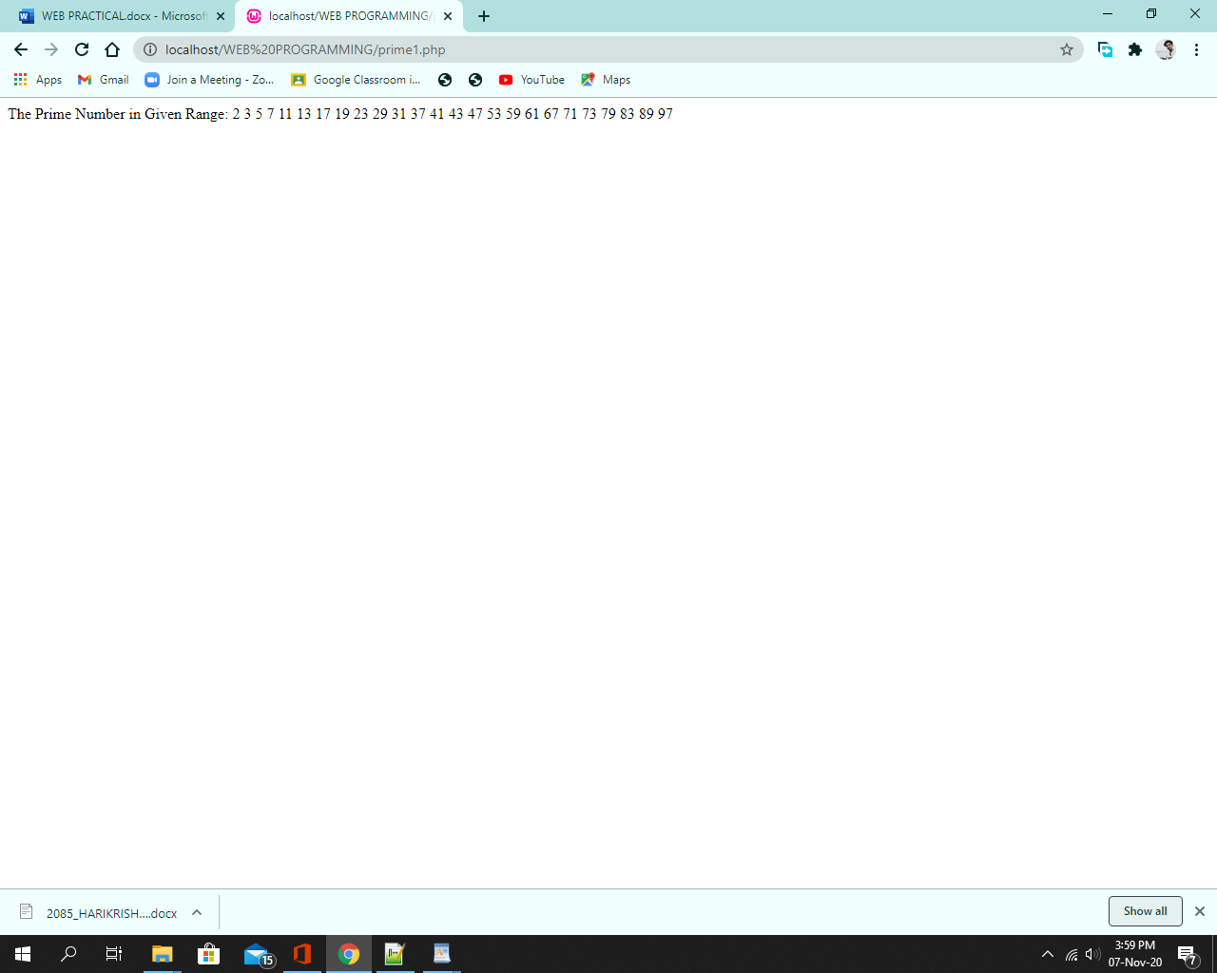

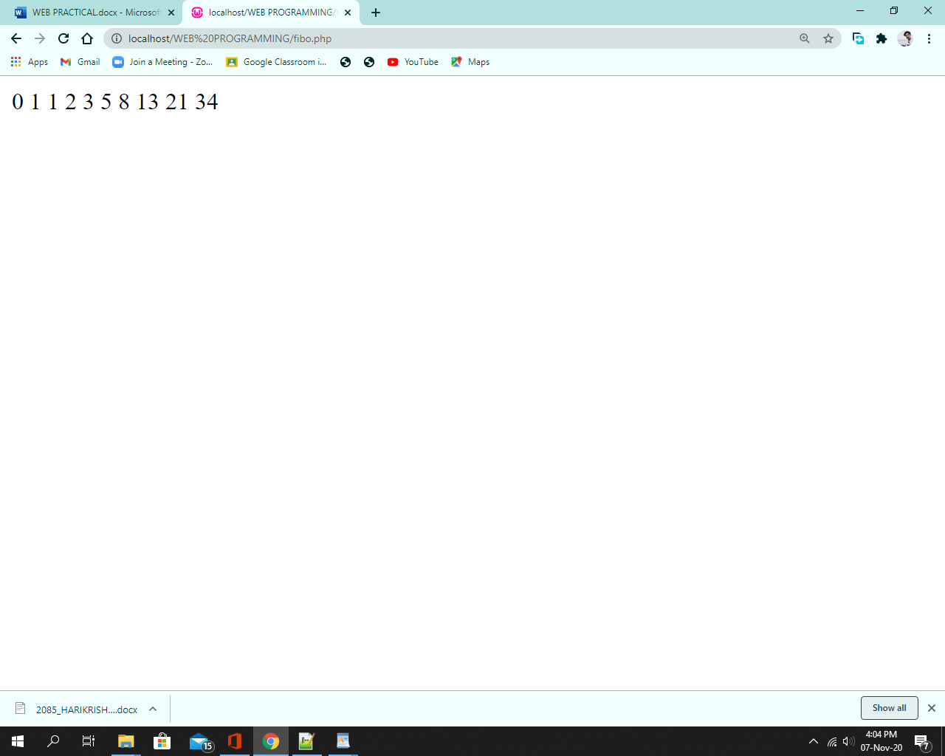

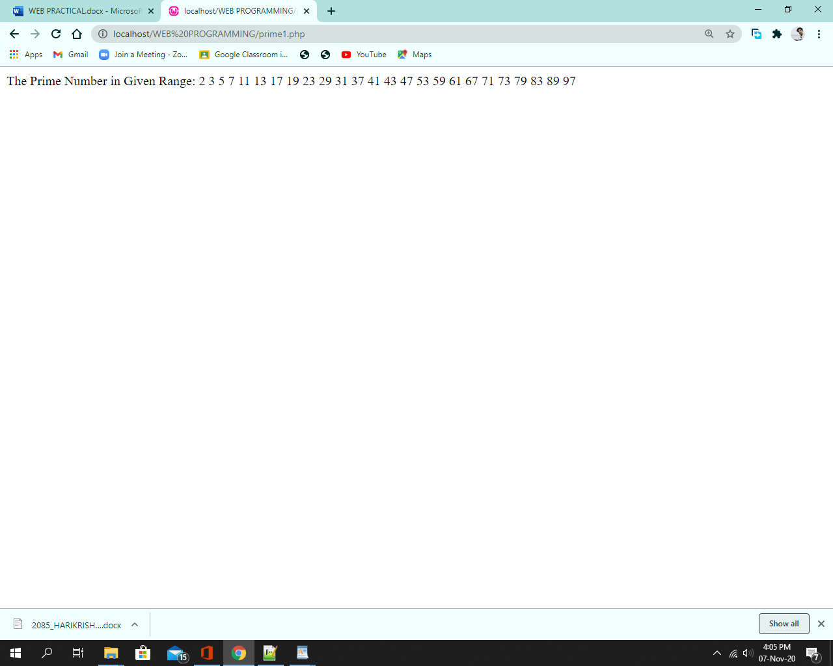

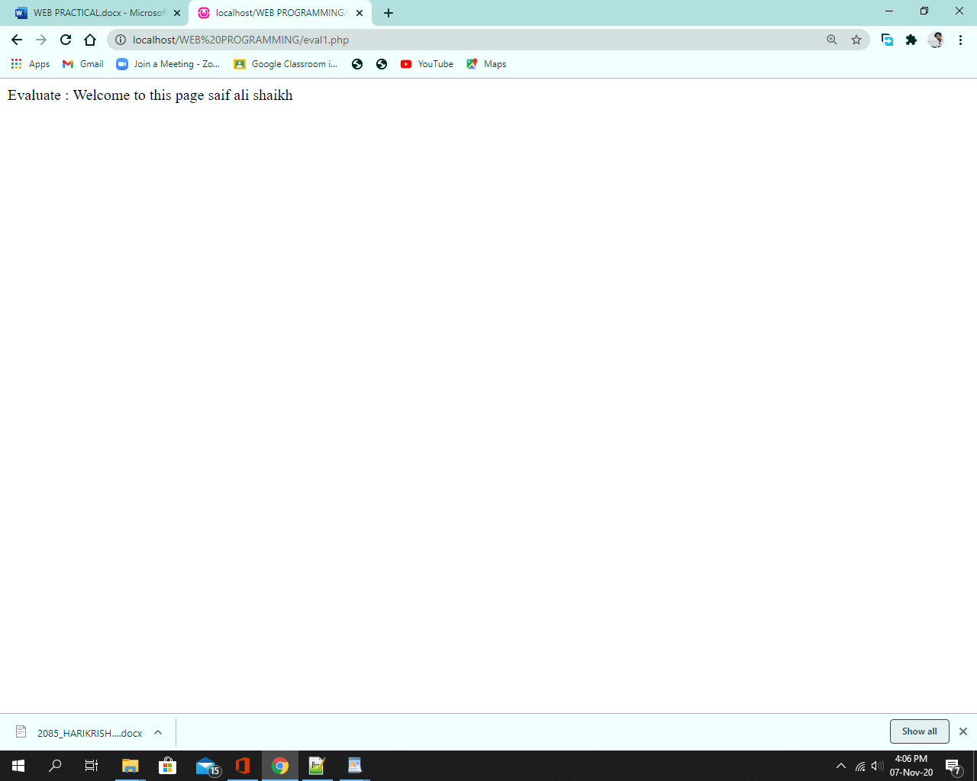

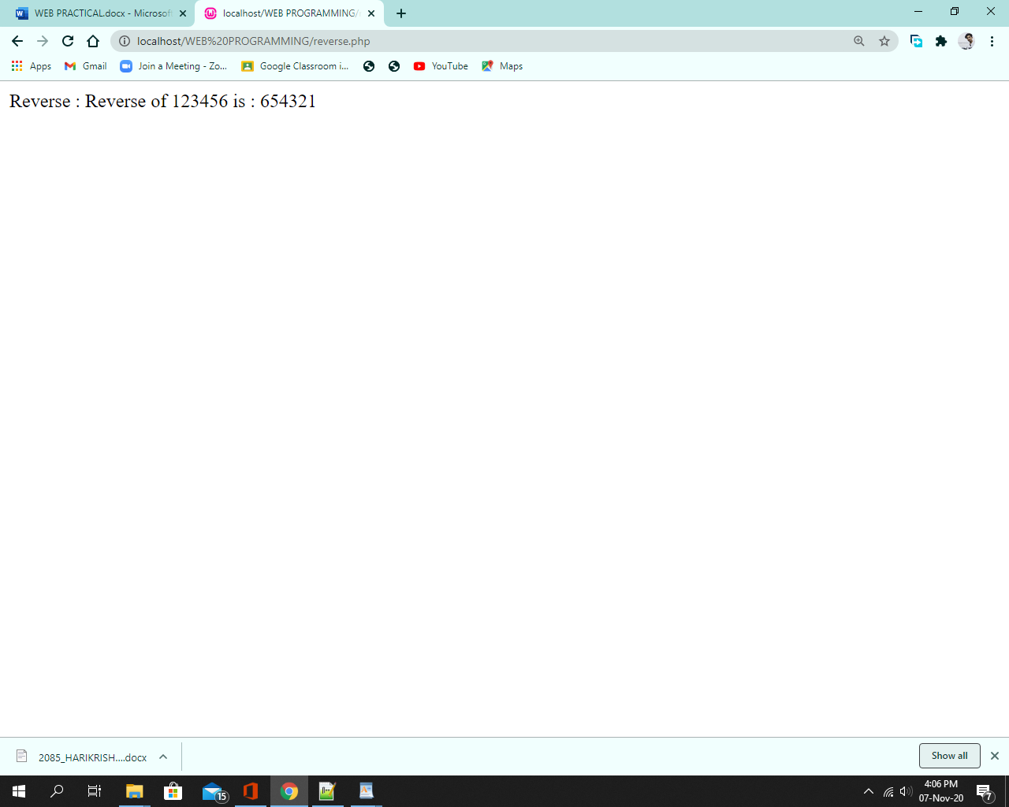

(c) Working with Arrays

<?php

$cars = array("BMW", "AUDI", "FERRARI");

$arrlength = count($cars);

echo "There are $arrlength car brand : <br>";

for($x = 0; $x < $arrlength; $x++)

{

echo $cars[$x];

echo "<br>";

}

?>

**Output:**

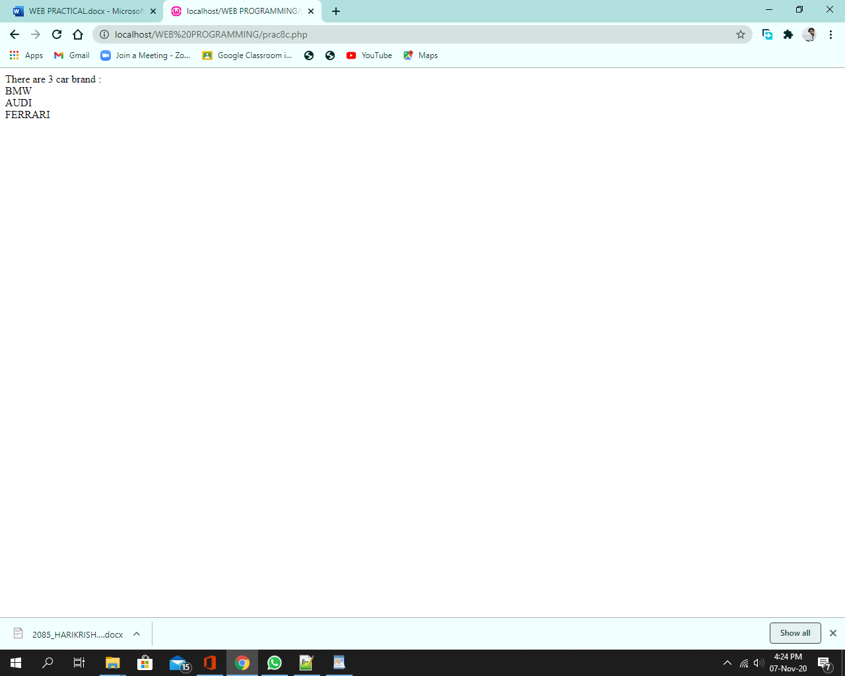

d. Working with Files (Reading / Writing) :

<!DOCTYPE html>

<html>

<head>

<title>Reading text from a file using PHP</title>

</head>

<body>

<h1>Reading text from a file using PHP</h1>

<?php

$myfile = fopen("test1.txt", "r");

while (!feof($myfile))

{

echo fgets($myfile)."<br>";

}

fclose($myfile);

?>

</body>

</html>

Output:

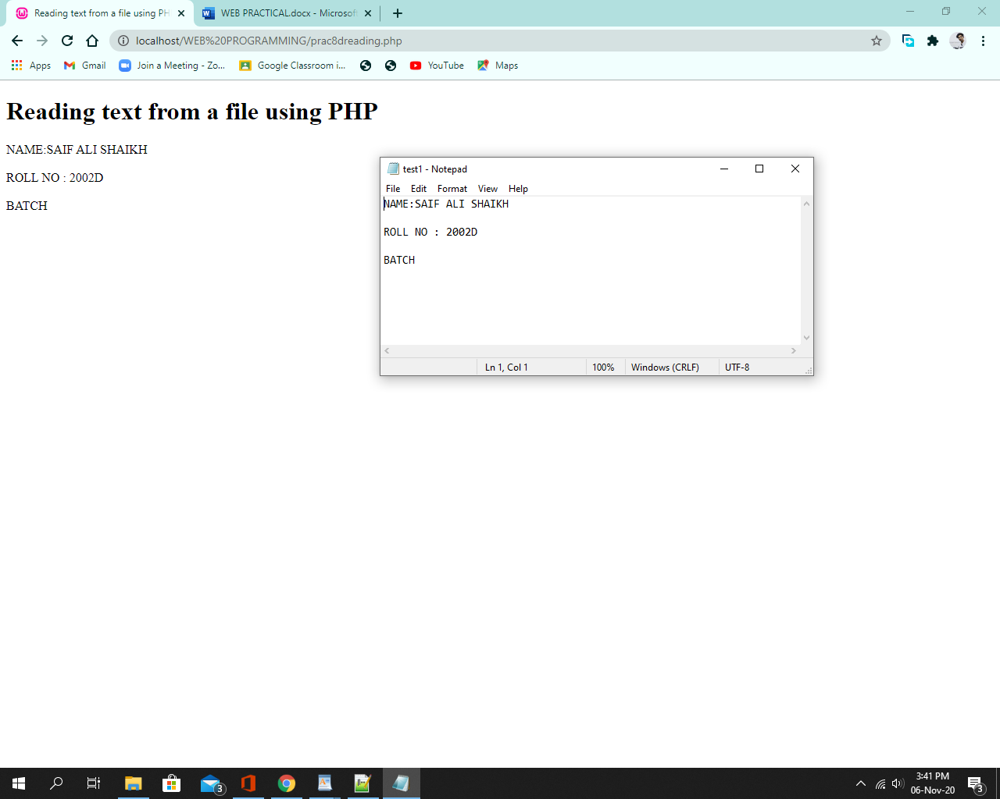

**Code:**

<!DOCTYPE html>

<html>

<head>

<title>Writing a file using PHP</title>

</head>

<body>

<center>

<h1>Writing a file using PHP</h1>

<?php

$myfile = fopen("test2.txt", "w");

$sent = "This line is added after writing to the file.";

if (fwrite($myfile, $sent) == FALSE)

{

echo "Can't find the file.";

}

else

{

echo "Text is wrote to the file!";

}

fclose($myfile);

?>

</center>

</body>

</html>

**Output**:

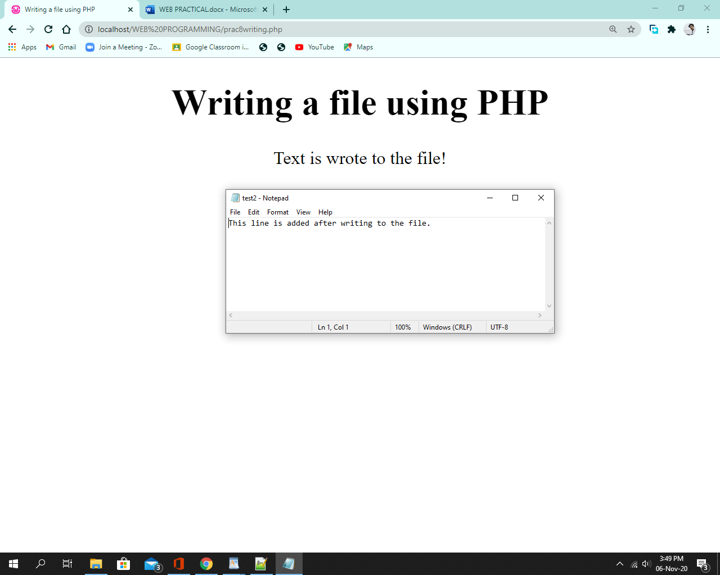

[**Practical 9**](http://pr9)

A . Working with Databases (Storing Records / Reprieving Records and Display them)

Code:

**Create:**

<?php

$servername = "localhost";

$username = "root";

$password = "";

$dbname = "mysql";

// Create connection

$conn = new mysqli($servername, $username, $password, $dbname); // Check connection

if ($conn->connect_error) {

die("Connection failed: " . $conn->connect_error);

}

// sql to create table

$sql = "CREATE TABLE st (

id INT(6) UNSIGNED AUTO_INCREMENT PRIMARY KEY, firstname VARCHAR(30) NOT NULL, lastname VARCHAR(30) NOT NULL,

email VARCHAR(50),

reg_date TIMESTAMP DEFAULT CURRENT_TIMESTAMP ON UPDATE CURRENT_TIMESTAMP )";

if ($conn->query($sql) === TRUE) {

echo "Table student created successfully";

} else {

echo "Error creating table: " . $conn->error;

}

$conn->close();

?>

**Output:**

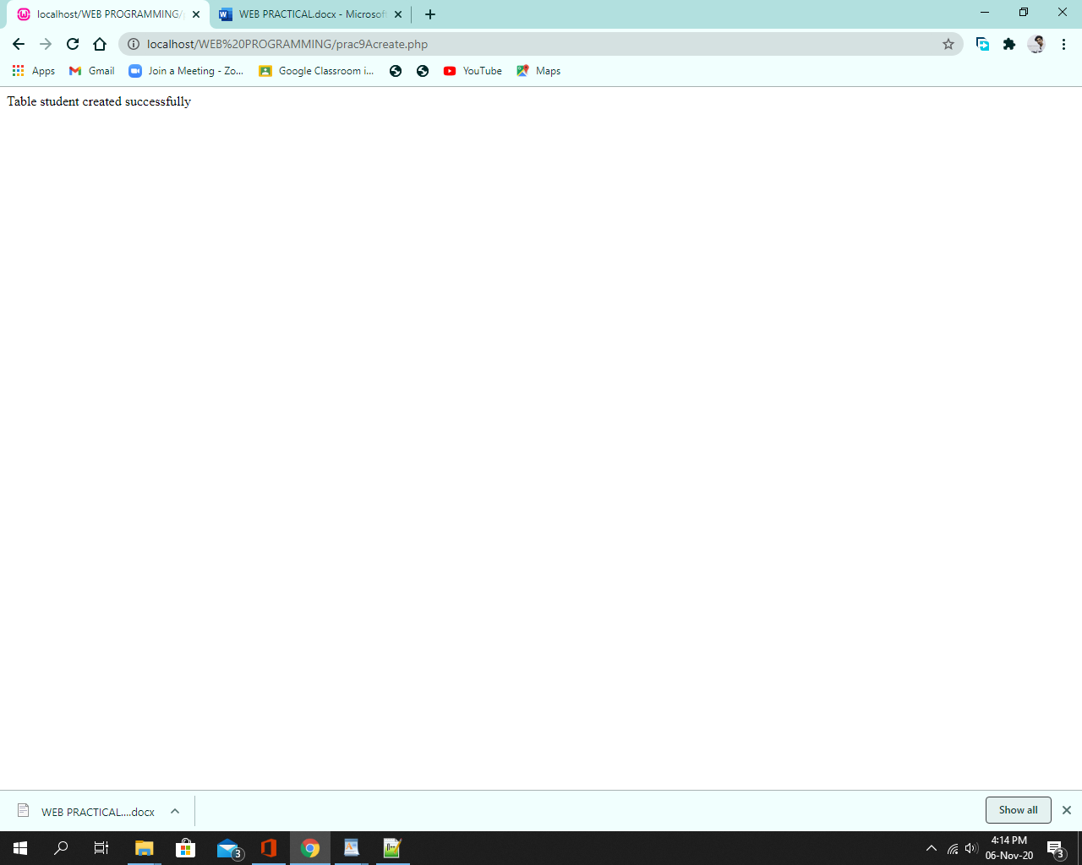

Code:

**Insert:**

<?php

$servername = "localhost";

$username = "root";

$password = "";

$dbname = "mysql";

// Create connection

$conn = new mysqli($servername, $username, $password, $dbname); // Check connection

if ($conn->connect_error) {

die("Connection failed: " . $conn->connect_error);

}

$sql = "INSERT INTO st (firstname, lastname, email) VALUES ('SAIF ALI', 'shaikh', '[saifali@gmail.com](mailto:saifali@gmail.com)'), ('vishal', 'nir', '[vishal1@gmail.com](mailto:vishal1@gmail.com)'), ('dipak', 'misra', '[dddlj@gmail.com](mailto:dddlj@gmail.com)')";

if ($conn->query($sql) === TRUE) {

echo "New record created successfully";

} else {

echo "Error: " . $sql . "<br>" . $conn->error;

}

$conn->close();

?>

**Output:**

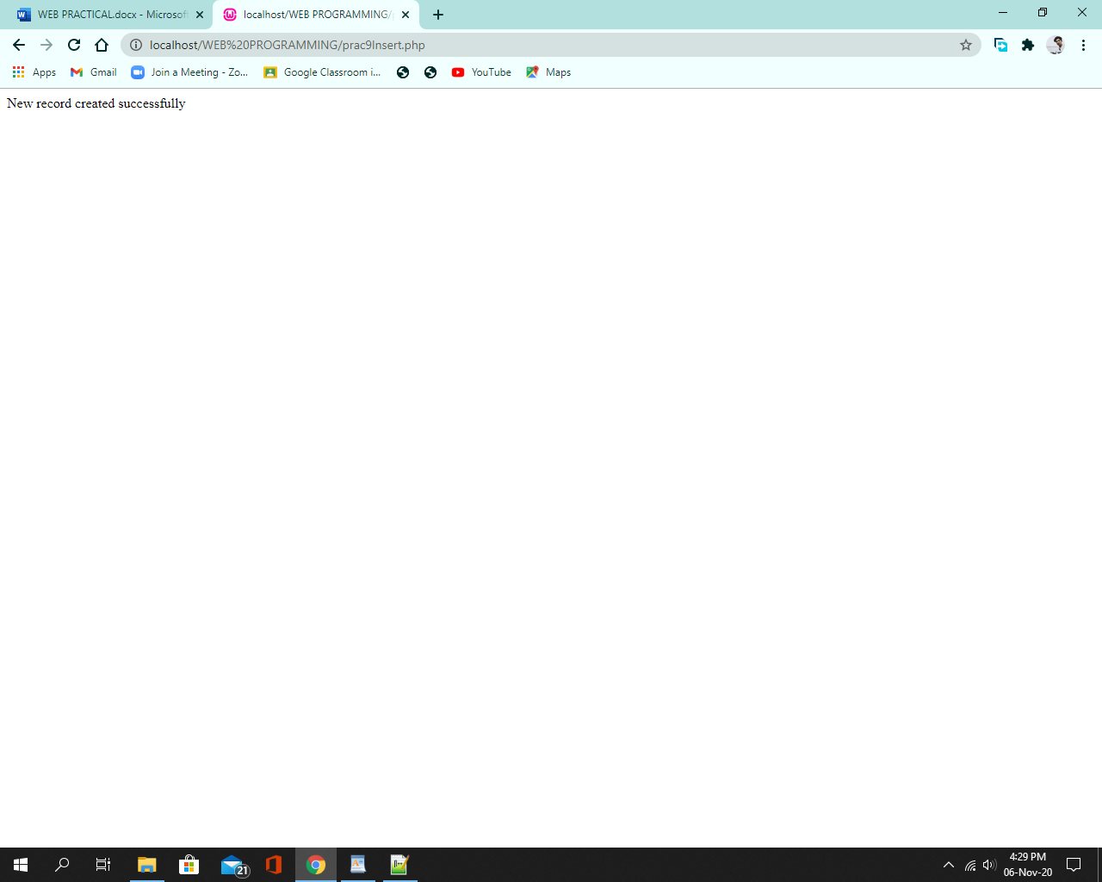

**Display:**

<?php

$servername = "localhost";

$username = "root";

$password = "";

$dbname = "mysql";

// Create connection

$conn = new mysqli($servername, $username, $password, $dbname); // Check connection

if ($conn->connect_error) {

die("Connection failed: " . $conn->connect_error);

}

$sql = "INSERT INTO st (firstname, lastname, email) VALUES ('SAIF ALI', 'shaikh', 'saifali@gmail.com'), ('vishal', 'nir', 'vishal1@gmail.com'), ('dipak', 'misra', 'dddlj@gmail.com')";

if ($conn->query($sql) === TRUE) {

echo "New record created successfully";

} else {

echo "Error: " . $sql . "<br>" . $conn->error;

}

$conn->close();

?>

**Output:**

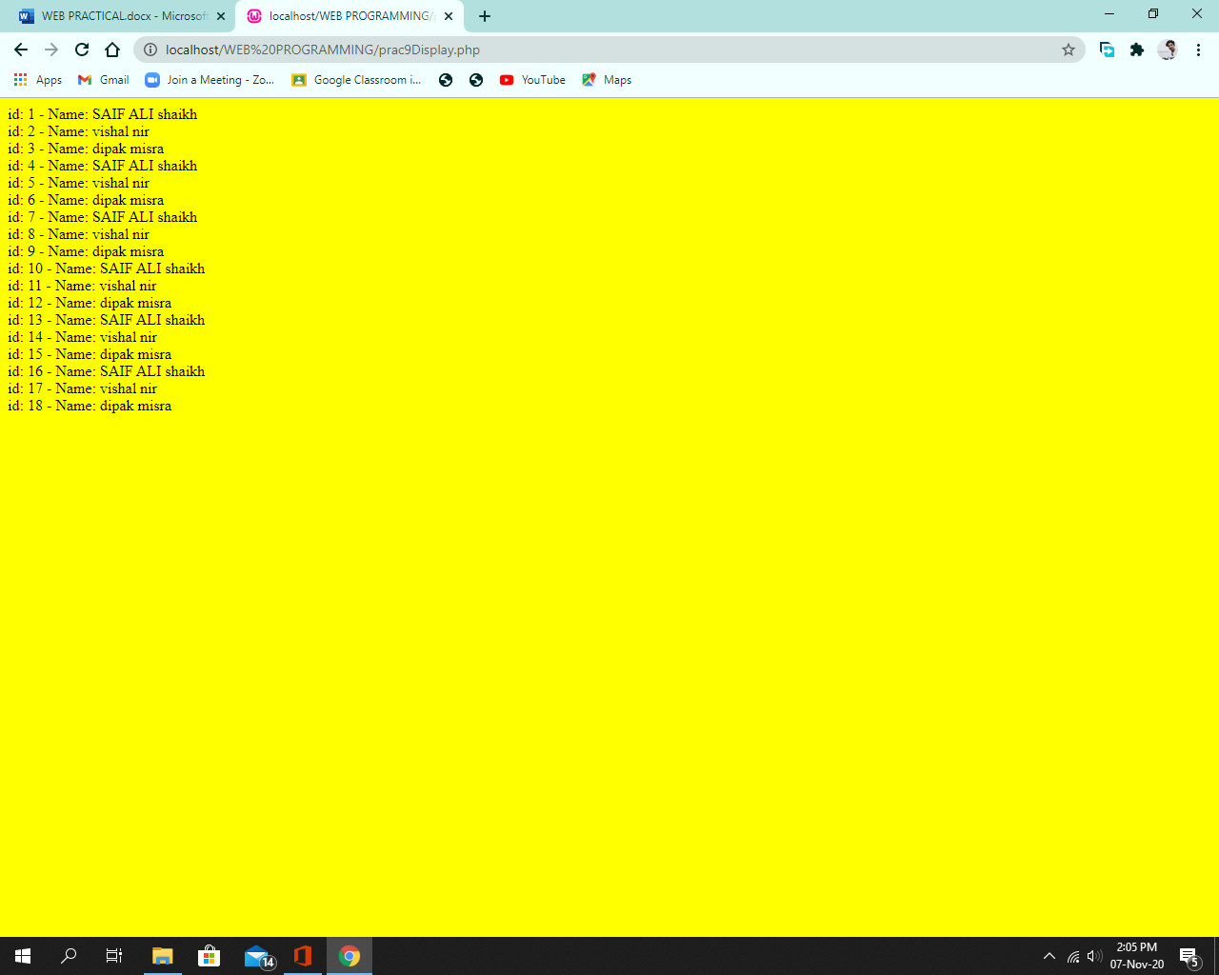

b. Storing and Retrieving Cookies

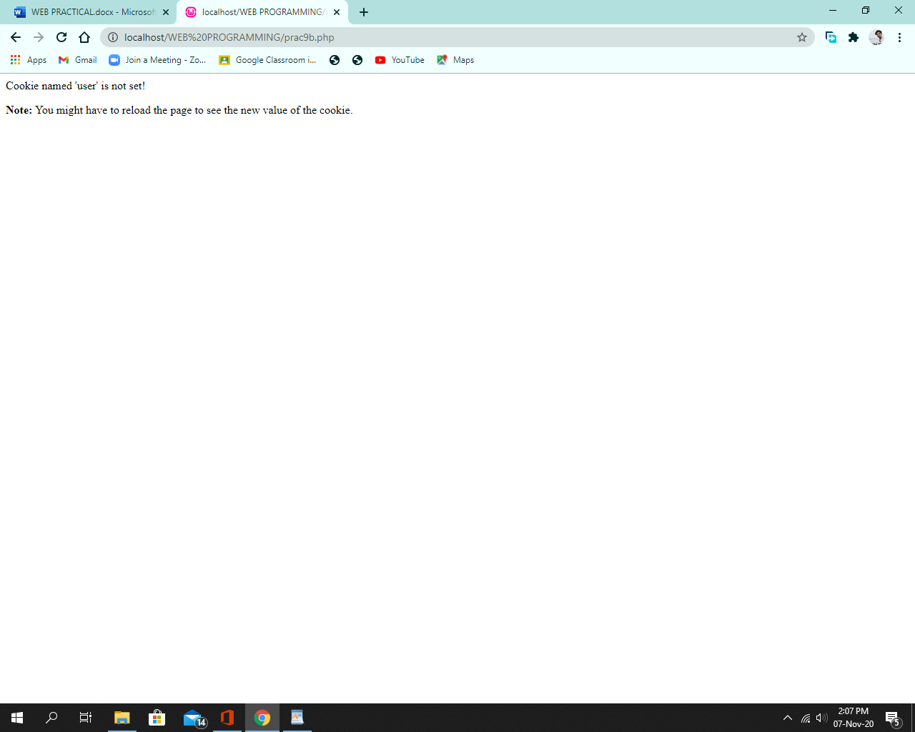

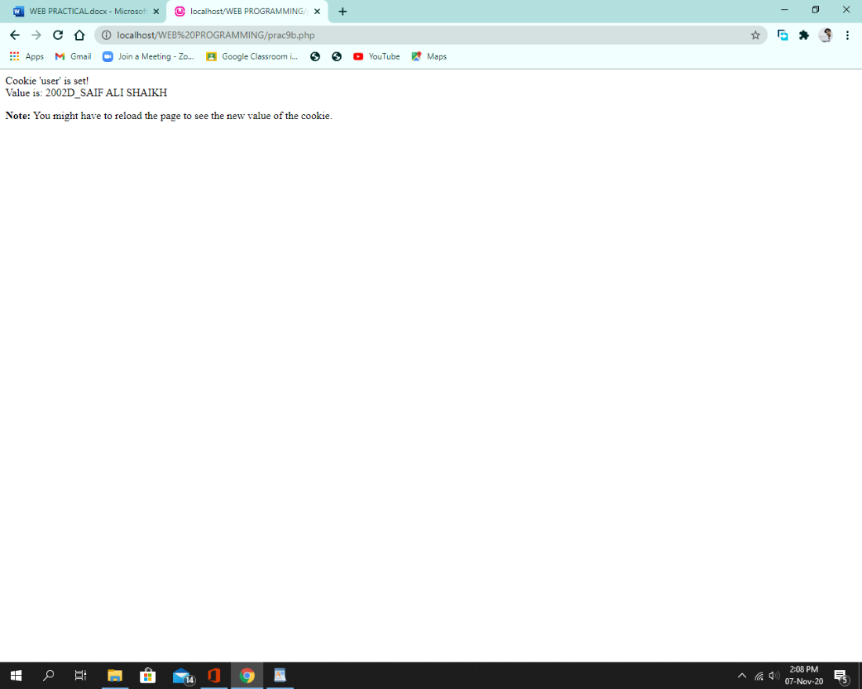

c. Storing and Retrieving Sessions

Session1:

Code:

<?php

// Start the session

session_start();

?>

<!DOCTYPE html> <html>

<body bgcolor="yellow">

<?php

// Set session variables

$_SESSION["name"] = "SAIF ALI SHAIKH ";

$_SESSION["roll no"] = "2002D";

echo "Session variables are set.";

?>

</body>

</html>

**Output:**

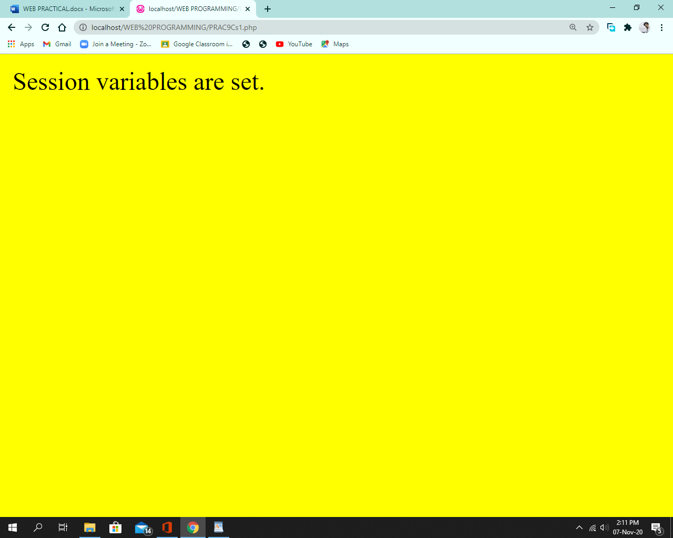

Session 2:

Code:

<?php

session_start();

?>

<!DOCTYPE html>

<html>

<body bgcolor ="yellow">

<h1>

<?php

//echo session variables that were set on previous page

echo "Name : " . $_SESSION["name"] . ".<br>";

echo "Roll No : " . $_SESSION["roll no"] . ".";

?>

</h1>

</body>

</html>

**Output:**

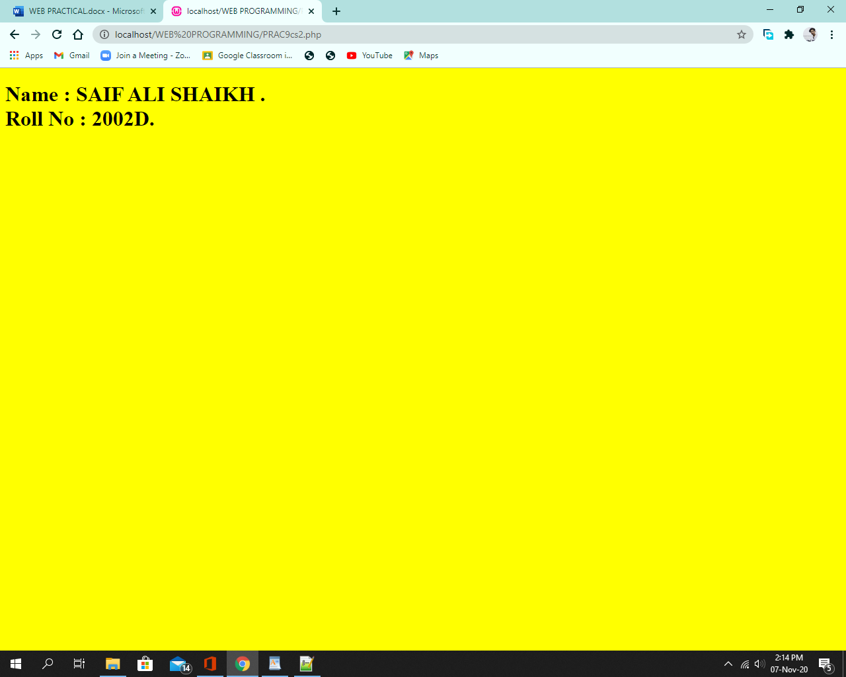

[**Practical 10**](http://pr10)

**Code:**

<!DOCTYPE html>

<html lang="en">

<head>

<meta charset="UTF-8">

<title>Example of jQuery Fade-In and Fade-Out Effects</title>

<script src="https://code.jquery.com/jquery-1.11.3.min.js"></script>

<style type="text/css">

p{

padding: 15px;

background: white;

}

</style>

<script type="text/javascript">

$(document).ready(function(){

// Fadeing out displayed paragraphs

$(".out-btn").click(function(){

$("p").fadeOut();

});

// Fading in hidden paragraphs

$(".in-btn").click(function(){

$("p").fadeIn();

});

});

</script>

</head>

<body bgcolor=yellow align="center">

<br><br>

<p>This is a paragraph.</p>

<p>This is another paragraph.</p>

<button type="button" class="out-btn">Fade Out Paragraphs</button>

<button type="button" class="in-btn">Fade In Paragraphs</button>

</body>

</html>

**Output:**

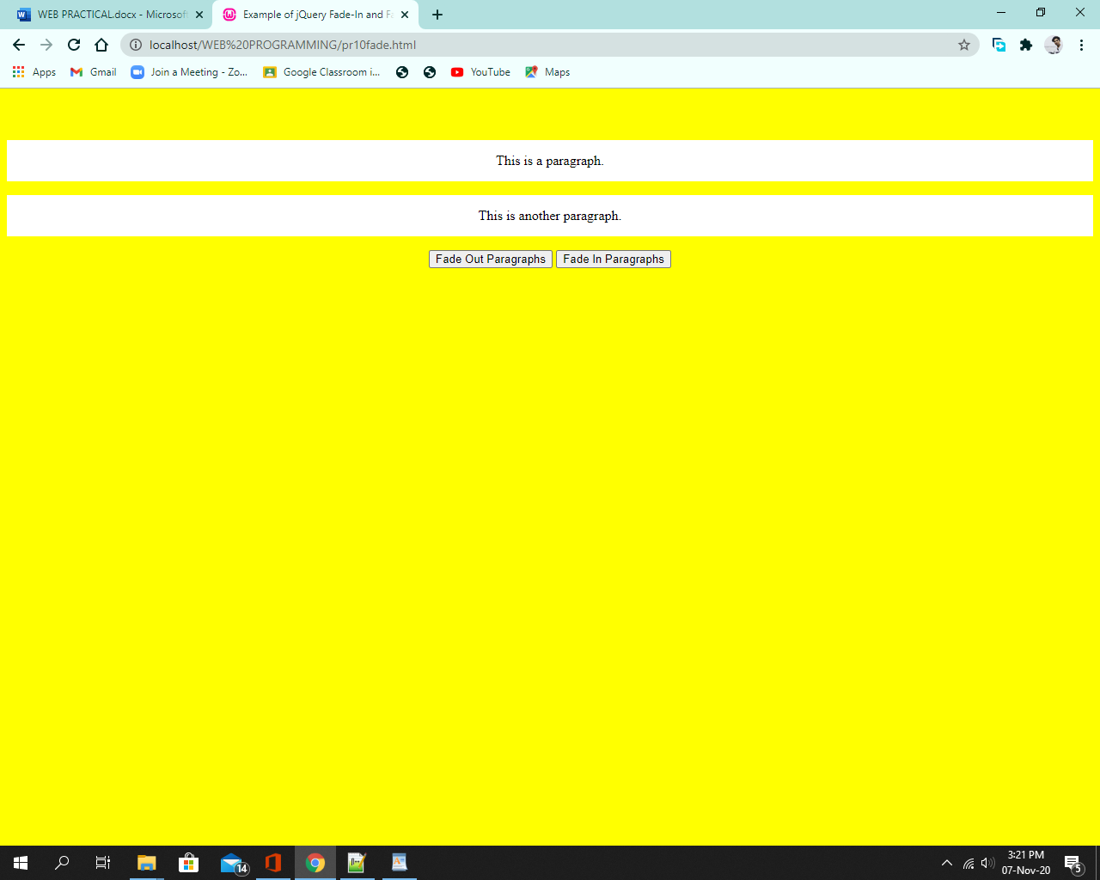

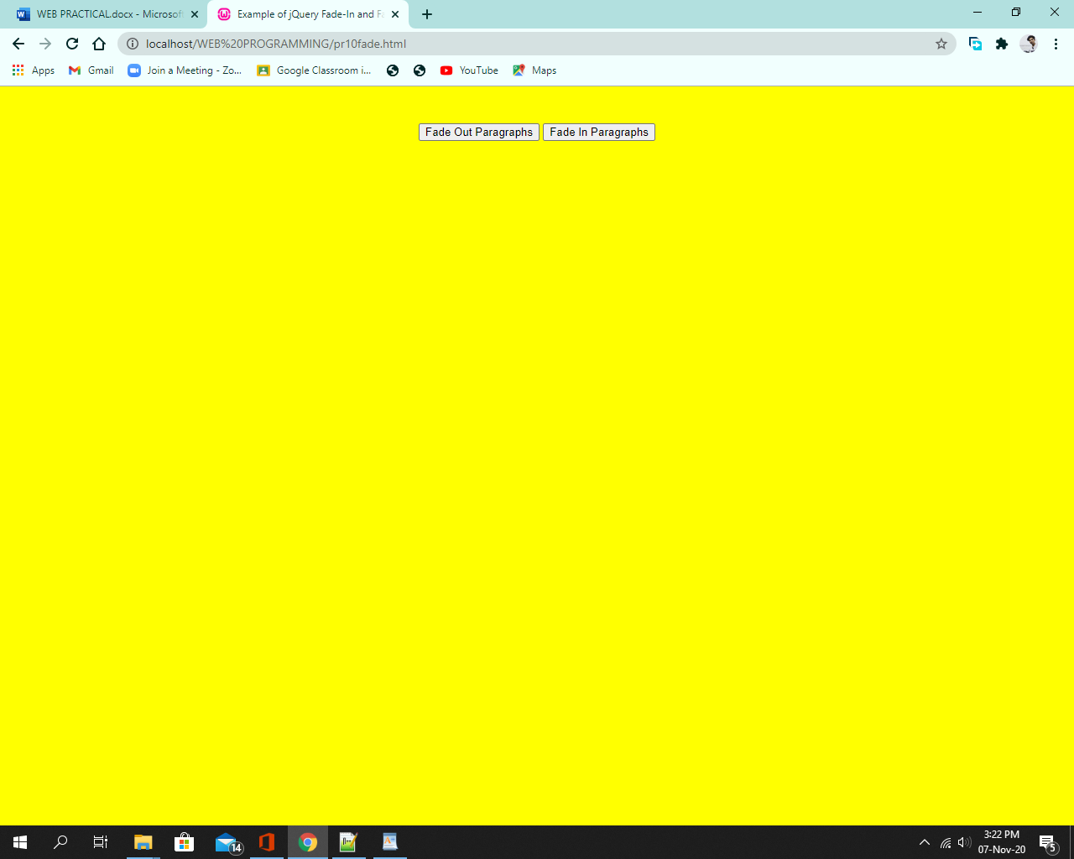

**Hide:**

<!DOCTYPE html>

<html lang="en">

<head>

<meta charset="UTF-8">

<title>Example of jQuery Show Hide Effects</title>

<script src="https://code.jquery.com/jquery-1.11.3.min.js"></script>

<style type="text/css">

p{

padding: 15px;

background: Grey;

}

</style>

<script type="text/javascript">

$(document).ready(function(){

// Hide displayed paragraphs

$(".hide-btn").click(function(){

$("p").hide();

});

// Show hidden paragraphs

$(".show-btn").click(function(){

$("p").show();

});

});

</script>

</head>

<body bgcolor="yellow" align="center">

<br><br>

<p>This is a paragraph.</p>

<p>This is another paragraph.</p>

<button type="button" class="hide-btn">Hide Paragraphs</button>

<button type="button" class="show-btn">Show Paragraphs</button>

</body>

</html>

**Output:**

